

USEFUL JAPANESE DICTIONARY FOR VIETNAMESE

SOFTWARE REQUIREMENT SPECIFICATION

**Project Code: UJD_VN**

**Document Code: UJD_VN_ Software requirement specification_v1.2_EN**

**- Hanoi, 06/2014 -**

Record of change

*A - Added M - Modified D - Deleted

|  |  |  |  |  |
| --- | --- | --- | --- | --- |
| Effective Date | Changed Items | A* M, D | Change Description | New Version |
| 30/06/2014 | Change 1.6 functional specification | M | Update functionality follow comments of supervisor. | v1.0 |
| 05/08/2014 | Change 1.5 Entity Relation Model | M | Update model | v1.1 |
| 11/08/2014 | Change 1.6 Functional Specification | M | Update screen | v1.2 |

**Signature page**

**Riginator** Nguyễn Ngọc Tuấn 23/06/2014

Team member

**Reviewer**  Nguyễn Ngọc Tuấn 11/08/2014

Team member

**Approval** Nguyễn Văn Sang 11/08/2014

Supervisor

Table of Contents

1.1 Introduction 4

1.1.1 Purposes 4

1.1.2 Definition and Acronyms 5

1.2 System Purpose 5

1.3 Scope 5

1.4 Overall Description 5

1.4.1 System overview 5

1.4.2 Product Features 7

1.4.3 User Characteristics 10

1.4.4 User Documentation 10

1.4.5 Assumption 10

1.5 Entity Relation Model 11

1.5.1 Entity-Relationship Diagram 11

1.5.2 Entity Detail 11

1.6 Functional Specification 16

1.6.1 Common Module 16

1.6.2 Account management Module 26

1.6.3 Contact admin Module 39

1.6.4 Practice management Module 48

1.6.5 Admin’s account management 59

1.6.6 Management Member’s account 66

1.6.7 Vocabulary Management 73

1.6.8 Grammar Management 86

1.6.9 Reading Document Management 98

1.6.10 Conversation management 115

1.6.11 Video Management 129

1.6.12 Training Listening Management 138

1.6.13 Test management 152

1.6.14 Contact management 165

1.6.15 Contributed content management 173

1.7 Non-functional Specification 181

1.7.1 Reliability 181

1.7.2 Performance Requirements 181

1.7.3 User Interface 181

1.7.4 Maintainability 182

1.7.5 Usability 182

1.7.6 Security Requirements 182

1.7.7 Hardware/Software Requirements 182

## Introduction

### Purposes

This document is created as the introduction for project Useful Japanese Dictionary for Vietnamese – our Capstone Project at FPT University. In this document, we will descript the overview of function list, use case of our software, a brief description about function's screen. This document help user understand more about our system

### Definition and Acronyms

This section describes the definitions, terms, and acronyms that are used in software requirements specification.

|  |  |
| --- | --- |
| Items | Description |
| UJD_VN | Useful Japanese dictionary for Vietnamese |
|  |  |
|  |  |

**Table 3-1: Definition and Acronyms**

## System Purpose

That system is developed to help user easily find out information about Japanese (grammar, vocabulary, etc...) and training skill, doing test.

## Scope

The scope of this project contains Requirement Analysis, Design, Coding and Testing (Unit Test, Integration Test, and System Test).

## Overall Description

### System overview

Nowadays, there are many dictionaries which support Japanese. That can be a website or mobile application. All of them have been created for the purpose of helping users search vocabulary or studying Japanese more easily. However, we found some disadvantages which existing in website, which support users studying Japanese. So, our project – UJD_VN will include some main functions of existing dictionary website and add some special features such as showing examples by Vietnamese, supporting searching specialized vocabulary or users can contribute idea, good knowledge to make our database become larger. Moreover, we will provide freely website to users. Here, we toward provide website for Vietnamese who want to studying Japanese communication or who want to join Japanese certification exams.

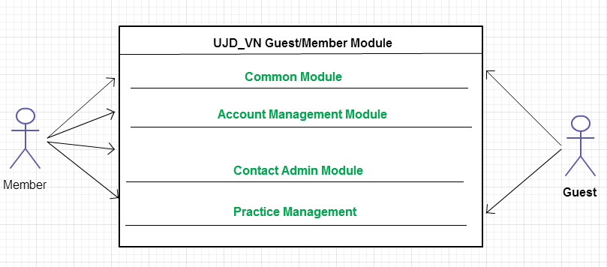

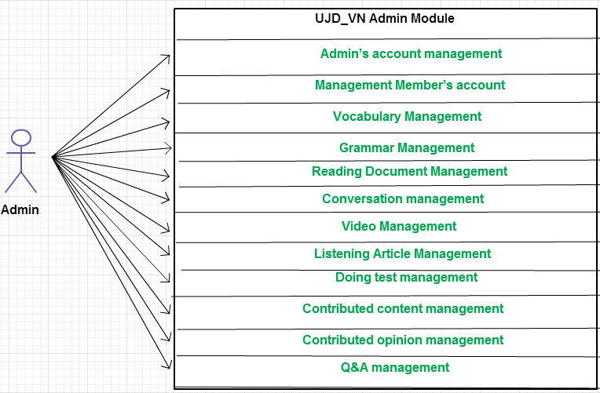

### Product Features

|  |  |  |  |
| --- | --- | --- | --- |
| **Use Case No.** | **Group of functions** | **Functions** | **Glossary** |
| **UJD_VN GUEST/MEMBER MODULE** | | | |
| **Common Module** | | | |
|  | Search | Search sentences | Tìm kiếm các mẫu câu ví dụ |
|  | Search conversation | Tìm kiếm các đoạn hội thoại |
|  | Search grammar | Tìm kiếm ngữ pháp |
|  | Search video | Tìm kiếm Video tiếng Nhật |
|  | Search specialized Japanese | Tìm kiếm Tiếng Nhật chuyền ngành |
| **Account Management Module** | | | |
|  | Login | Login by Facebook account | Đăng nhập bằng tài khoản Facebook |
| Login by Google account | Đăng nhập bằng tài khoản Google |
| Login by registered account | Đăng nhập bằng tài khoản tự đăng kí |
|  |  | Logout | Đăng xuất |
|  |  | Register | Đăng kí tài khoản cho khách để sử dụng nhiều chức năng hơn của website |
|  |  | Edit Profile | Chỉnh sửa thông tin cá nhân |
|  |  | Forgot Password | Quên mật khẩu |
| **Contact Admin Module** | | | |
|  | Contact Admin | Contribute content | Đóng góp database hữu ích cho website |
|  | Contribute opinion | Đóng góp ý kiến để phát triển trang web |
|  | Send Q & A | Gửi câu hỏi thắc mắc trong quá trình sử dụng Website |
| **Practice Management** | | | |
|  | Doing Test | Test | Làm bài kiểm tra trắc nghiệm |
| Tracking mark | Theo dõi quá trình học tập |
|  |  | Training Listening | Luyện Nghe trình độ N2,N3,N4 |
|  |  | Listening conversation | Nghe hội thoại |
|  |  | Reading Document | Đọc tài liệu |
| **UJD_VN ADMIN MODULE** | | | |
|  | Admin’s account management | Add new admin | Thêm mới admin |
|  | Edit profile | Chỉnh sửa thông tin admin |
|  | Delete admin | Xóa thông tin admin |
|  | Management Member’s account | Search member | Tìm kiếm thành viên |
|  | Ban/Unban Member’s account | Khóa/Mở khóa tài khoản thành viên |
|  | Delete member | Xóa thành viên |
|  | Vocabulary Management | Search vocabulary | Tìm kiếm từ vựng |
|  | Add vocabulary | Thêm mới từ vựng |
|  | Edit vocabulary | Chỉnh sửa thông tin từ vựng |
|  | Delete vocabulary | Xóa từ vựng |
|  | Grammar Management | Search grammar | Tìm kiếm ngữ pháp |
|  | Add Grammar | Thêm ngữ pháp mới |
|  | Edit grammar | Chỉnh sửa ngữ pháp |
|  | Delete Grammar | Xóa ngứ pháp |
|  | Reading Document Management | Search reading document | Tìm kiếm các bài đọc |
|  | Add reading document | Thêm mới các bài đọc |
|  | Edit reading document | Chỉnh sửa thông tin các bài đọc |
|  | Delete reading document | Xóa các bài đọc |
|  | Conversation management | Search conversation | Tìm kiếm các bài hội thoại |
|  | Add conversation | Thêm mới bài hội thoại |
|  | Edit conversation | Chỉnh sửa bài hội thoại |
|  | Delete conversation | Xóa bài hội thoại |
|  | Video Management | Search Video | Tìm kiếm Video bằng tiêu đề |
|  | Add Video | Thêm mới video |
|  | Edit Video | Chỉnh sửa nội dung liên quan đến video như tiêu đề. |
|  | Delete Video | Xóa video |
|  | Listening Article Management | Search listening article | Tìm kiếm các bài nghe |
|  | Add listening article | Thêm mới các bài nghe |
|  | Edit listening article | Chỉnh sửa các bài nghe |
|  | Delete listening article | Xóa các bài nghe |
|  | Doing test management | Search test | Tìm kiếm bài kiểm tra |
|  | Add test | Thêm mới bài kiểm tra |
|  | Edit test | Chỉnh sửa bài kiếm tra |
|  | Delete test | Xóa bài kiểm tra |
| **Contact’s Content Management** | | | |
|  | Contributed content management | Search contribute content | Tìm kiếm nội dung đóng góp |
| Approve content | Chấp nhận ý kiến đóng góp |
| Reply user | Trả lời người dùng |
| Delete content | Xóa nội dung đóng góp |
|  | Contributed opinion management | Search contribute opinion | Tìm kiếm ý kiến đóng góp |
| Reply user | Phản hồi lại ý kiến người dùng |
| Delete opinion | Xóa ý kiến đóng góp |
|  | Q & A Management | Search Q & A | Tìm kiếm Q & A |
| Reply Q & A | Trả lời Q & A |
| Delete Q & A | Xóa Q & A |

### User Characteristics

This website developed towards those who have achieved elementary level Japanese and want to improve intermediate level. The website requires users to have the ability to use a browser with an internet connection. Use can easy use the functions in website, but if they want to use all function, they must be login.

### User Documentation

List of document when delivering this application is in the table below:

|  |  |
| --- | --- |
| Name | Description |
| User Manual | Provide detailed explanation about the system, screens and guide users how to use all features of UJD_VN website. |

### Assumption

* Receive the guidance and good support of teacher.
* No one of member got sick in the software development process.
* In the development process, no device got fail.
* Every report meets the deadline.
* Team member do not conflict in the work process.

## Entity Relation Model

### Entity-Relationship Diagram

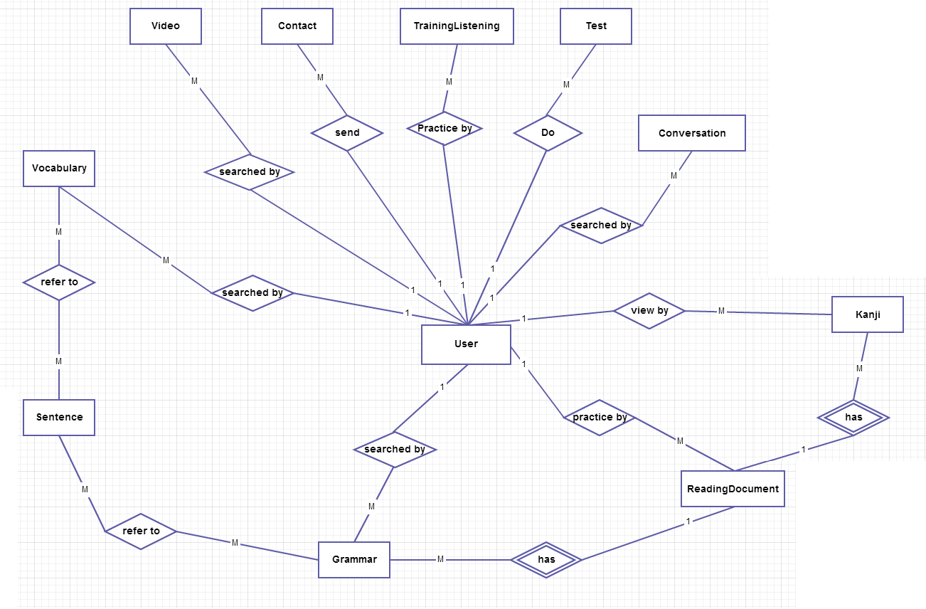

### Entity Detail

#### Vocabulary

|  |  |  |  |  |
| --- | --- | --- | --- | --- |
| No | Field Name | Type | Mandatory | Description |
|  | id | Number | Y | Vocabulary’s id |
|  | Hiragana | String | Y | Vocabulary’s hiragana |
|  | Romaji | String | Y | Vocabulary’s romaji |
|  | Meaning | String | Y | Vocabulary’s meaning |
|  | Category | String | Y | Vocabulary’s category |
|  | Kanji | String |  | Vocabulary’s kanji |
|  | Specialized | String |  | Vocabulary’s specialized |
|  | Status | Number | Y | Vocabulary’s status |

#### Sentence

|  |  |  |  |  |
| --- | --- | --- | --- | --- |
| No | Field Name | Type | Mandatory | Description |
|  | ID | Number | Y | Sentence’s id |
|  | Hiragana | String | Y | Sentence’s hiragana |
|  | Romaji | String | Y | Sentence’s romaji |
|  | Meaning | String | Y | Sentence’s meaning |
|  | Kanji | String | Y | Sentence’s kanji |

#### Grammar

|  |  |  |  |  |
| --- | --- | --- | --- | --- |
| No | Field Name | Type | Mandatory | Description |
|  | ID | Number | Y | Grammar’s id |
|  | Hiragana | String | Y | Grammar’s hiragana |
|  | Romaji | String | Y | Grammar’s romaji |
|  | Level | String | Y | Grammar’s level |
|  | Meaning | String | Y | Grammar’s meaning |
|  | Use | String | Y | Grammar’s use |
|  | Lesson | String |  | Grammar’s lesson |
|  | Status | Number | Y | Grammar’s status |

#### Video

|  |  |  |  |  |
| --- | --- | --- | --- | --- |
| No | Field Name | Type | Mandatory | Description |
|  | ID | Number | Y | Video’s id |
|  | Title | String | Y | Video’s title |
|  | Link | String | Y | Video’s link |

#### Kanji

|  |  |  |  |  |
| --- | --- | --- | --- | --- |
| No | Field Name | Type | Mandatory | Description |
|  | ID | Number | Y | Kanji’s id |
|  | Kanji | String | Y | Kanji in Japanese |
|  | Hanviet | String | Y | Kanji’s Vietnamese-Han |
|  | Onyomi | String | Y | Kanji’s onyomi |
|  | Kunyomi | String |  | Kanji’s kunyomi |
|  | Meaning | String | Y | Kanji’s meaning |
|  | Level | String | Y | Kanji’s level |
|  | Lesson | String |  | Kanji’s lesson |
|  | Status | Number | Y | Kanji’s status |

#### Conversation

|  |  |  |  |  |
| --- | --- | --- | --- | --- |
| No | Field Name | Type | Mandatory | Description |
|  | ID | Number | Y | Conversation’s id |
|  | Titel | String | Y | Conversation’s level |
|  | Level | String | Y | Conversation’s title |
|  | Content | String | Y | Conversation’s content |
|  | Audio | String | Y | Conversation’s audio |
|  | Image | String |  | Conversation’s image |

#### User

|  |  |  |  |  |
| --- | --- | --- | --- | --- |
| No | Field Name | Type | Mandatory | Description |
|  | ID | Number | Y | User’s id |
|  | Username | String | Y | Username login |
|  | Password | String | Y | Store password login of user.  Using md5 algorithm. |
|  | Role | Number | Y | Admin can assign permission for user |
|  | Full name | String |  | User’s name be displayed |
|  | Email | String | Y | User’s email |
|  | Register date | Date | Y | Date register |
|  | Status | Number | Y | Active or deactive |

#### Test

|  |  |  |  |  |
| --- | --- | --- | --- | --- |
| No | Field Name | Type | Default | Description |
|  | ID | Number | Y | Test’s id |
|  | Title | String | Y | Test’s category |
|  | Level | String | Y | Test’s level |
|  | Category | String | Y | Test’s category |
|  | Content | String |  | Test’s content |
|  | Question | String | Y | Test’s question |
|  | Answer | String | Y | Question’s answer |

#### Contact

|  |  |  |  |  |
| --- | --- | --- | --- | --- |
| No | Field Name | Type | Mandatory | Description |
|  | ID | Number | Y | Contact’s id |
|  | Email | String | Y | Contact’s email |
|  | Content | String | Y | Contact’s content |
|  | Type | String | Y | Contact’s type |
|  | Reply | String |  | Contact’s reply |
|  | Status | Number | Y | Contact’s status |

#### Training Listening

|  |  |  |  |  |
| --- | --- | --- | --- | --- |
| No | Field Name | Type | Mandatory | Description |
|  | ID | Number | Y | Listening’s id |
|  | Title | String | Y | Listening’s title |
|  | Level | String | Y | Listening’s level |
|  | File | String | Y | Listening’s file |
|  | Question | String | Y | Listening’s question |
|  | Script | String | Y | Listening’s script |
|  | Meaning | String | Y | Listening’s meaning |
|  | Answer | String | Y | Listening’s answer |

#### Reading document

|  |  |  |  |  |
| --- | --- | --- | --- | --- |
| No | Field Name | Type | Mandatory | Description |
|  | ID | Number | Y | Reading’s id |
|  | Title | String | Y | Reading’s title |
|  | Level | String | Y | Reading’s level |
|  | Vocabulary | String | Y | Reading’s vocabulary |
|  | Grammar | String | Y | Reading’s grammar |
|  | Kanji | String | Y | Reading’s kanji |
|  | Article | String | Y | Reading’s article |

## Functional Specification

### Account management Module

#### Use Case Diagram

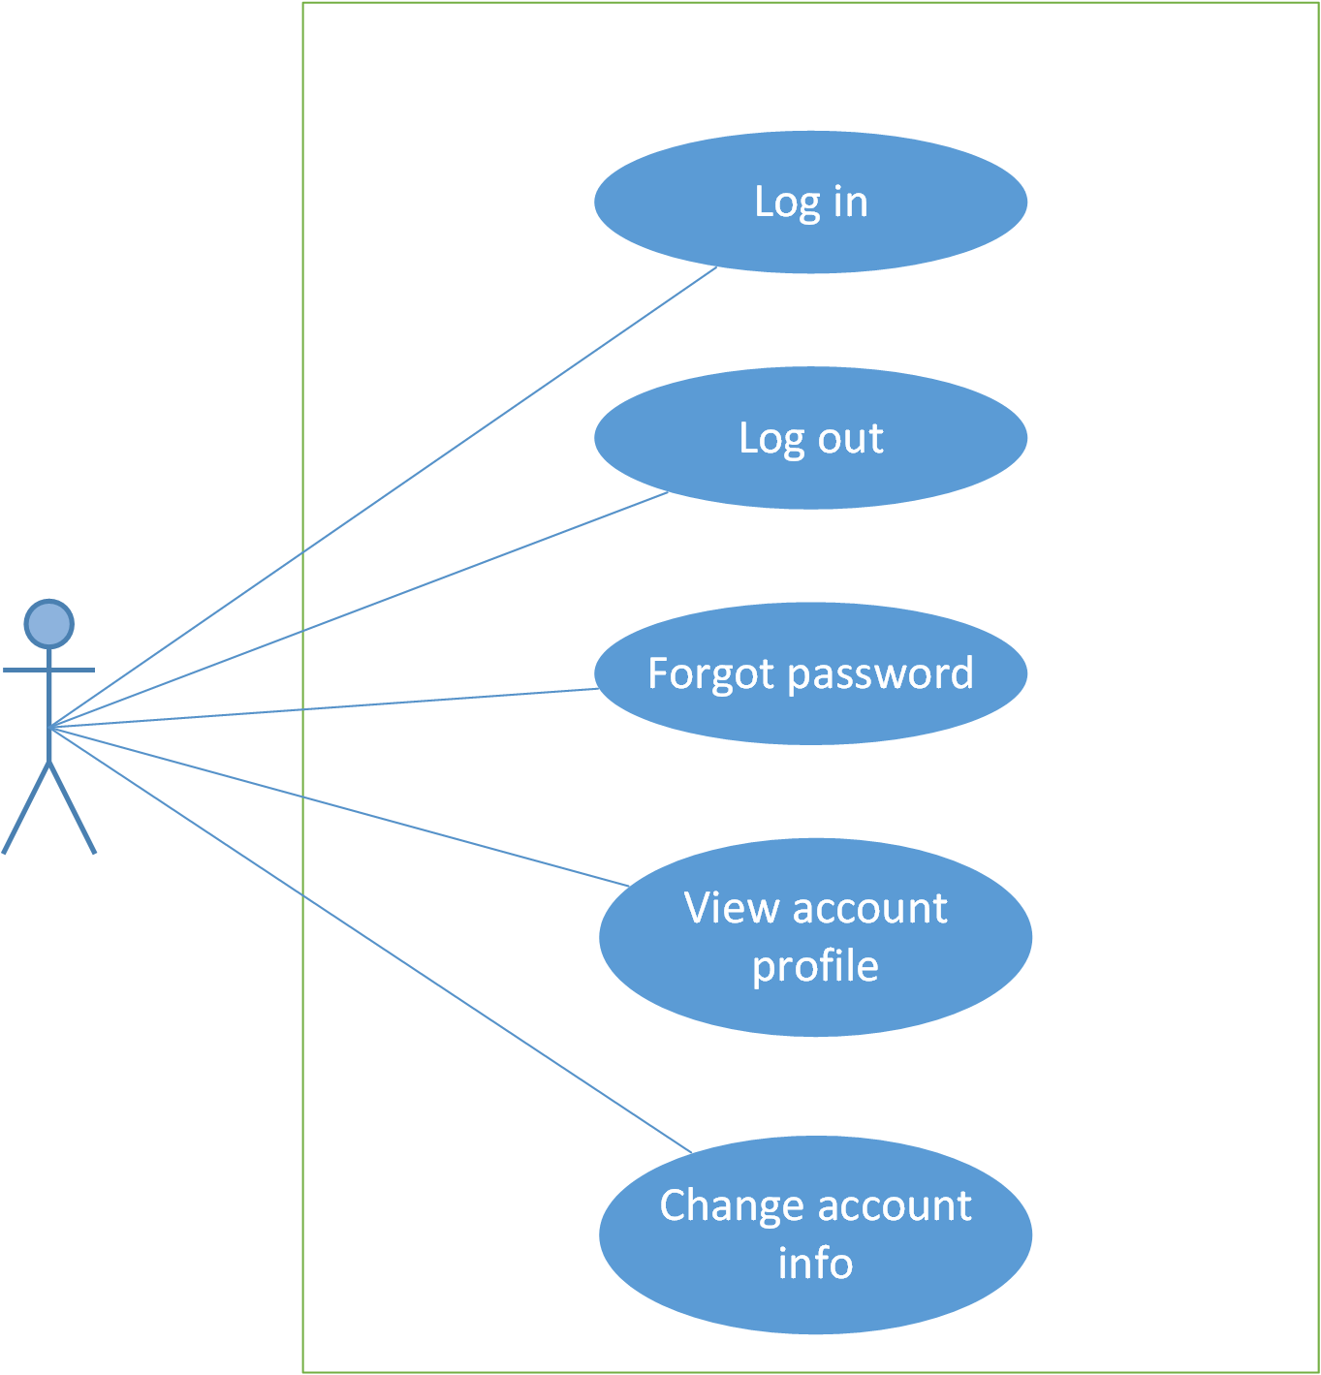

#### Use Case Specification

##### UC006: Login

|  |  |  |  |  |
| --- | --- | --- | --- | --- |
| **UC006 – Login** | | | | |
| **Use-case No.** | <UC006> | **Use-case Version** | | <1.0> |
| **Use-case Name** | Login | | | |
| **Author** | Anh TT | | | |
| **Date** | 28/05/2015 | **Priority** | <High > | |
| **Actor:**  User  **Summary:**  When User want to login by account to use more functions in app  **Triggers**  User choose the login method, input data and click on “Login” button  **Preconditions:**   * User’ phone must be have internet * Account must be exist and correctly   **Post Conditions:**  Login successfully and redirect user to previous app.  **Main Success Scenario:**   |  |  |  | | --- | --- | --- | | **Step** | **User** | **System** | | 1 | Enter website link on web browser | Be displayed Homepage screen | | 2 | Choose login method ( login by Facebook/register account), input account and password and then click “Đăng nhập” button | Validate information and log user into system. |     **Alternative Scenario:**   |  |  |  | | --- | --- | --- | | **At Step** | **User** | **System** | | 2 | Input data in username and password area then click on another link | Switch to selected page |   **Exceptions:**   |  |  |  | | --- | --- | --- | | **At Step** | **User** | **System** | | 3 | Fill incorrect or missing information “Tên đăng nhập”/ “Mật khẩu” field | Return Error message beside “Tên đăng nhập”/ “Mật khẩu” field. | | | | | |

##### UC007: Logout

|  |  |  |  |  |
| --- | --- | --- | --- | --- |
| **UC007 – Logout** | | | | |
| **Use-case No.** | <UC007> | **Use-case Version** | | <1.0> |
| **Use-case Name** | Logout | | | |
| **Author** | Anh TT | | | |
| **Date** | 28/02/2015 | **Priority** | <High > | |
| **Actor:**  User  **Summary:**  When User want to logout their account  **Triggers**  Click on logout button  **Preconditions:**   * User’ phone must have internet * User must be login   **Post Conditions:**  Redirect user to previous app.  **Main Success Scenario:**   |  |  |  | | --- | --- | --- | | **Step** | **User** | **System** | | 1 | Click on logout button | Redirect to homepage | | | | | |

##### UC010: Forgot password

|  |  |  |  |  |
| --- | --- | --- | --- | --- |
| **UC010 – Forgot password** | | | | |
| **Use-case No.** | <UC010> | **Use-case Version** | | <1.0> |
| **Use-case Name** | Forgot password | | | |
| **Author** | Anh TT | | | |
| **Date** | 28/05/2015 | **Priority** | <High > | |
| **Actor:**  User  **Summary:**  When User forgot their password to login the app, this function will receive their password to email  **Triggers**  Click on forgot password link on the app  **Preconditions:**  User’ phone must have internet  **Post Conditions:**  Receiving their password to their email  **Main Success Scenario:**   |  |  |  | | --- | --- | --- | | **Step** | **User** | **System** | | 1 | Enter website link on web browser | Be displayed Homepage screen | | 2 | Click on “Quên mật khẩu link. | Be displayed “Quên mật khẩu” page | | 3 | Enter necessary and mandatory information in the “Quên mật khẩu” form and click "Gửi yêu cầu" button. | System will send the password into your email. |     **Alternative Scenario:**   |  |  |  | | --- | --- | --- | | **At Step** | **User** | **Syste** | | 3 | Enter necessary and mandatory information and click another link | Switch to selected page |   **Exceptions:**   |  |  |  | | --- | --- | --- | | **At Step** | **User** | **System** | | 3 | Enter email incorrect with email that use to register account | Be displayed error message and request to re-enter email | | | | | |
|  | | | | |

##### UC008: View profile

|  |  |  |  |  |
| --- | --- | --- | --- | --- |
| **UC008 – View profile** | | | | |
| **Use-case No.** | <UC008> | **Use-case Version** | | <1.0> |
| **Use-case Name** | View profile | | | |
| **Author** | Anh TT | | | |
| **Date** | 28/05/2015 | **Priority** | <High > | |
| **Actor:**  User  **Summary:**  User can view their profile  **Triggers**  Click on View profile on the app  **Preconditions:**  User’ phone must have internet and login the app  **Post Conditions:**  System will show user’ profile  **Main Success Scenario:**   |  |  |  | | --- | --- | --- | | **Step** | **User** | **System** | | 1 | Enter website link on web browser | Be displayed Homepage screen | | 2 | Click on register link | Be displayed register form | | 3 | Enter necessary and mandatory information and click "Đăng kí" button. | Be displayed message to register successfully and redirect to homepage |     **Alternative Scenario:**   |  |  |  | | --- | --- | --- | | **At Step** | **User** | **System** | | 3 | Enter necessary and mandatory information and click another link | Switch to selected page |   **Exceptions:**   |  |  |  | | --- | --- | --- | | **At Step** | **User** | **System** | | 3 | Missing “Tên đăng nhập” field and click “Đăng kí” button | Be displayed error message beside “Tên đăng nhập” field. | | 3 | Enter incorrect information or missing “Mật khẩu” field and click “Đăng kí” button | Be displayed error message beside “Mật khẩu” field. | | 3 | Missing “Họ và tên” field and click “Đăng kí” button | Be displayed error message beside “Họ và tên” field. | | 3 | Missing “Email” field and click “Đăng kí” button | Be displayed error message eside “Email” field. | | 3 | Enter incorrect information or missing “Mã xác nhận” field and click “Đăng kí” button | Be displayed error message beside “Mã xác nhận” field. | | | | | |

##### UC009: Change account info

Figure 2.4: Edit profile

|  |  |  |  |  |
| --- | --- | --- | --- | --- |
| **UC009 – Change account info** | | | | |
| **Use-case No.** | <UC009> | **Use-case Version** | | <1.0> |
| **Use-case Name** | Change account info | | | |
| **Author** | Anh TT | | | |
| **Date** | 28/05/2015 | **Priority** | <High > | |
| **Actor:**  User  **Summary:**  When member want to change their account info  **Triggers**  Login the website and click on the edit profile link  **Preconditions:**  User’ phone must have internet  User login the app  **Post Conditions:**  Change account info successful and redirect user to changed account page  **Main Success Scenario:**   |  |  |  | | --- | --- | --- | | **Step** | **User** | **System** | | 1 | Enter website link on web browser | Be displayed Homepage screen | | 2 | Enter necessary and mandatory information and click "Login” | Redirect to previous page and logged user into system. | | 3 | Click on "Trang cá nhân" link. | Be displayed “Trang cá nhân” page | | 4 | User changes profile and click “Lưu” button | Update new profile |     **Alternative Scenario:**   |  |  |  | | --- | --- | --- | | **t Step** | **User** | **System** | | 4 | Enter necessary and mandatory information and click another link | Switch to selected page |   **Exceptions:**   |  |  |  | | --- | --- | --- | | **At Step** | **User** | **System** | | 4 | Enter new password that incorrect form or missing information and click “Lưu” button | Be displayed error message | | 4 | Enter new email that incorrect form or missing information and click “Lưu” button | Be displayed error message | | | | | |

### Interactive Module

#### Use case diagram

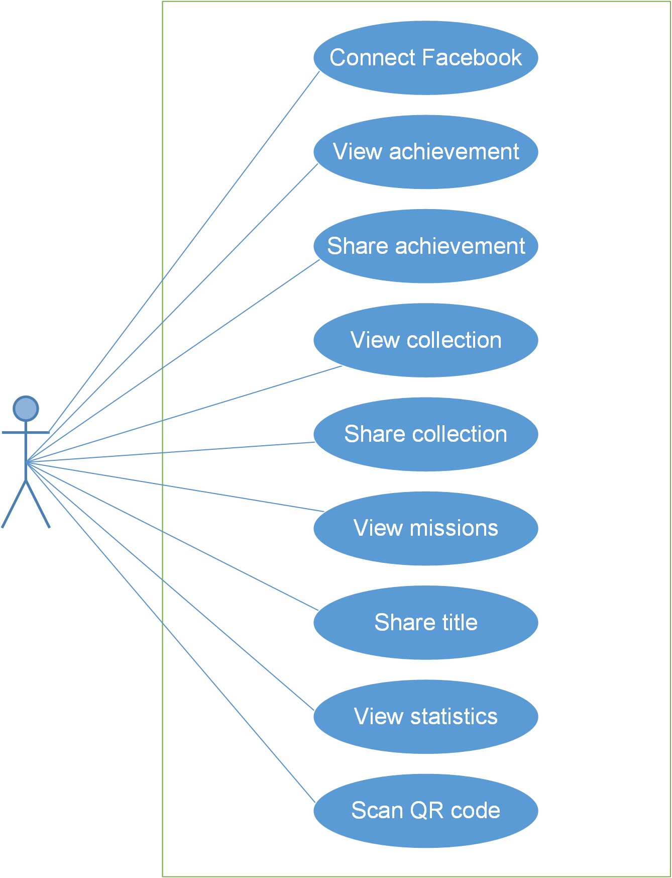

#### Use Case Specification

##### UC011: Connect facebook

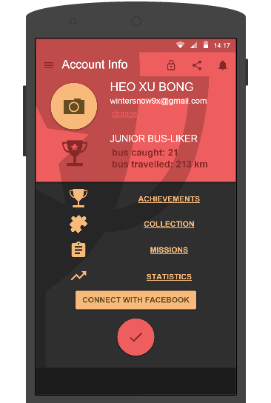

Figure 3.1: Connect facebook

|  |  |  |  |  |  |  |  |
| --- | --- | --- | --- | --- | --- | --- | --- |
| **No** | **Field name** | **Field name in Vietnamese** | **Type** | **Require** | **Mandatory** | **Max-Length** | **Description** |
| 1 | Connect Facebook | Kết nối với Facebook | Text | Click | Y |  | User click on Connect With Facebook to connect to their facebook. |
| 2 | View Achievement | Xem Thành tích | Text | Cick | Y |  | User click on Achievement to view achievement |
| 3 | Share Achievement | Chia sẻ Thành tích | Button | Click | Y |  | User lick share to share their achievement on facebook. |
| 4 | View Collection | Xem Bộ sưu tập | Text | Click | Y |  | User click on Collection to view Collection |
| 5 | Share Collection | Chia sẻ Bộ sưu tập | Button | Click | Y |  | User lick share to share their Collection on facebook. |
| 6 | View Missions | Xem Nhiệm vụ | Text | Click | Y |  | User click on Missions to view their Missions |

Table 3.1: Account ìno’s screen description

|  |  |  |  |  |
| --- | --- | --- | --- | --- |
| **UC011 – Connect facebook** | | | | |
| **Use-case No.** | <UC011> | **Use-case Version** | | <1.0> |
| **Use-case Name** | Connect facebook | | | |
| **Author** | Anh TT | | | |
| **Date** | 29/05/2015 | **Priority** | <High > | |
| **Actor:**  User  **Summary:**  When User want to connect to their facebook  **Triggers**  User click on Connect With Facebook button  **Preconditions:**  User’ phone must have internet  User must be login to the app  **Post Conditions:**  Connected to user’s facebook.  **Main Success Scenario:**   |  |  |  | | --- | --- | --- | | **Step** | **User** | **System** | | 1 | Enter website link on web browser | Be displayed Homepage screen | | 2 | Enter necessary and mandatory information and click "Login” | Redirect to previous page and logged user into system. | | 3 | Click on “Liên hệ”->”Đóng góp database” section | Be displayed “Đóng góp database” page | | 4 | Enter information that member want to contribute for the website then click “Đóng góp” | System will receive contributions |     **Alternative Scenario:**   |  |  |  | | --- | --- | --- | | **At Step** | **User** | **ystem** | | 4 | Enter necessary and mandatory information and click another link | Switch to selected page |   **Exceptions:**   |  |  |  | | --- | --- | --- | | **At Step** | **User** | **System** | | 4 | Missing “Nhập từ” field and click “Đóng góp” button | Be displayed error message beside “Nhập từ” field. | | 4 | Missing “Loại từ” field and click “Đóng góp” button | Be displayed error message beside “Loại từ” field. | | 4 | Missing “Nhập nghĩa” field and click “Đóng góp” button | Be displayed error message beside “Nhập nghĩa” field. | | 4 | Enter incorrect information or missing “Mã xác nhận” field and click “Đóng góp” button | Be displayed error message beside “Mã xác nhận” field. | | | | | |

##### UC012: View Achievement

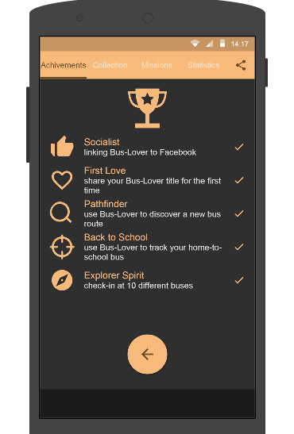

Figure 3.2: View Achievement

|  |  |  |  |  |  |  |  |
| --- | --- | --- | --- | --- | --- | --- | --- |
| **No** | **Field name** | **Field name in Vietnamese** | **Type** | **Require** | **Mandatory** | **Max-Length** | **Description** |
| 1 | Socialist | Xã Hội | Text | Text | Y |  | Linking Bus-Lover to Facebook. |
| 2 | First Love |  | Text | Text | Y |  | Share the Bus-Love title for the first time. |
| 3 | Pathfinder |  | Text | Text | Y |  | Use Bus-Lover to discover to a new bus route. |
| 4 | Back to school |  | Text | Text | Y |  | Use Bus-Lover to track your home-to-school bus |
| 5 | Explorer Spirit |  | Text | Text | Y |  | Check-in at 10 different buses. |
| 6 | ← | ← | Button | Click | Y |  | Click to back page |

Table 3.2: Achievement’s screen description

|  |  |  |  |  |
| --- | --- | --- | --- | --- |
| **UC012 – Contribute opinion** | | | | |
| **Use-case No.** | <UC012> | **Use-case Version** | | <1.0> |
| **Use-case Name** | View Achievement | | | |
| **Author** | Anh TT | | | |
| **Date** | 29/05/2015 | **Priority** | <High > | |
| **Actor:**  User  **Summary:**  When User want to view Achievement  **Triggers**  User click on Achievements to view  **Preconditions:**   * User’ phone must have internet * User must be login to the app   **Post Conditions:**  Achievements screen will be displayed.  **Main Success Scenario:**   |  |  |  | | --- | --- | --- | | **Step** | **Use** | **System** | | 1 | Enter website link on webbrowser | Be displayed Homepage screen | | 2 | Enter necessary and mandatory information and click "Login” | Redirect to previous page and logged user into system. | | 3 | Click on “Liên hệ”->”Đóng góp ý kiến” tab | Be displayed “Đóng góp ý kiến” page | | 4 | Enter information that member want to contribute for the website then click “Đóng góp” | System will receive contributions |   **Alternative Scenario:**   |  |  |  | | --- | --- | --- | | **At Step** | **User** | **System** | | 4 | Enter necessary and mandatory information and click another link | Switch to selected page |   **Exceptions:**   |  |  |  | | --- | --- | --- | | **At Step** | **User** | **System** | | 4 | Missing “Nhập email” field and click “Đóng góp” button | Be displayed error message beside “Nhập email” field. | | 4 | Missing “Nhập nội dung:” field and click “Đóng góp” button | Be displayed error message beside “Nhập nội dung:” field. | | 4 | Enter incorrect information or missing “Mã xác nhận” field and click “Đóng góp” button | Be displayed error message beside “Mã xác nhận” field. | | | | | |

##### UC013: Share Achievements

|  |  |  |  |  |
| --- | --- | --- | --- | --- |
| **UC013 – Share Achievements** | | | | |
| **Use-case No.** | <UC013> | **Use-case Version** | | <1.0> |
| **Use-case Name** | Share Achievements | | | |
| **Author** | Anh TT | | | |
| **Date** | 29/05/2015 | **Priority** | <High > | |
| **Actor:**  User  **Summary:**  When user want to share their Achievements  **Triggers**  Click on Share symbol.  **Preconditions:**  User’ phone must have internet  User must be login to the app  **Post Conditions:**  Achievements will be shared.  **Main Success Scenario:**   |  |  |  | | --- | --- | --- | | **Step** | **User** | **System** | | 1 | Enter website link on web browser | Be displayed Homepage screen | | 2 | Enter necessary and mandatory information and click "Login” | Redirect to previous page and logged user into system. | | 3 | Click on “Q&A” tab | Be displayed “Q&A” page | | 4 | Enter necessary and mandatory information in the “Q&A” form and click "Gửi" button. | Be displayed this Q&A in the “Q&A”section. |     **Alternative Scenario:**   |  |  |  | | --- | --- | --- | | **At Step** | **User** | **System** | | 4 | Enter necessary and mandatory information and click another link | Switch to selected page |   **Exceptions:**   |  |  |  | | --- | --- | --- | | **At Step** | **User** | **System** | | 4 | Missing “Nhập email” field and click “Đóng góp” button | Be displayed error message beside “Nhập email” field. | | 4 | Missing “Q&A” field and click “Đóng góp” button | Be displayed error message beside “Q&A” field. | | 4 | Enter incorrect information or missing “Mã xác nhận” field and click “Đóng góp” button | Be displayed error message beside “Mã xác nhận” field. | | | | | |
|  | | | | |

##### UC014: View Collection

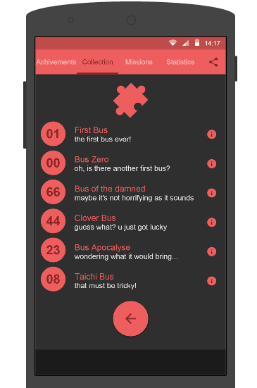

Figure 3.3: View Collection

|  |  |  |  |  |
| --- | --- | --- | --- | --- |
| **UC012 – View collection** | | | | |
| **Use-case No.** | <UC012> | **Use-case Version** | | <1.0> |
| **Use-case Name** | View collection | | | |
| **Author** | Anh TT | | | |
| **Date** | 29/05/2015 | **Priority** | <High > | |
| **Actor:**  User  **Summary:**  When User want to view collection  **Triggers**  User click on collection to view  **Preconditions:**   * User’ phone must have internet * User must be login to the app   **Post Conditions:**  collection screen will be displayed.  **Main Success Scenario:**   |  |  |  | | --- | --- | --- | | **Step** | **Use** | **System** | | 1 | Enter website link on webbrowser | Be displayed Homepage screen | | 2 | Enter necessary and mandatory information and click "Login” | Redirect to previous page and logged user into system. | | 3 | Click on “Liên hệ”->”Đóng góp ý kiến” tab | Be displayed “Đóng góp ý kiến” page | | 4 | Enter information that member want to contribute for the website then click “Đóng góp” | System will receive contributions |   **Alternative Scenario:**   |  |  |  | | --- | --- | --- | | **At Step** | **User** | **System** | | 4 | Enter necessary and mandatory information and click another link | Switch to selected page |   **Exceptions:**   |  |  |  | | --- | --- | --- | | **At Step** | **User** | **System** | | 4 | Missing “Nhập email” field and click “Đóng góp” button | Be displayed error message beside “Nhập email” field. | | 4 | Missing “Nhập nội dung:” field and click “Đóng góp” button | Be displayed error message beside “Nhập nội dung:” field. | | 4 | Enter incorrect information or missing “Mã xác nhận” field and click “Đóng góp” button | Be displayed error message beside “Mã xác nhận” field. | | | | | |

##### UC015: Share collection

|  |  |  |  |  |
| --- | --- | --- | --- | --- |
| **UC013 – Share Collection** | | | | |
| **Use-case No.** | <UC013> | **Use-case Version** | | <1.0> |
| **Use-case Name** | Share Collection | | | |
| **Author** | Anh TT | | | |
| **Date** | 29/05/2015 | **Priority** | <High > | |
| **Actor:**  User  **Summary:**  When user want to share their Collection  **Triggers**  Click on Share symbol.  **Preconditions:**  User’ phone must have internet  User must be login to the app  **Post Conditions:**  Collection will be shared.  **Main Success Scenario:**   |  |  |  | | --- | --- | --- | | **Step** | **User** | **System** | | 1 | Enter website link on web browser | Be displayed Homepage screen | | 2 | Enter necessary and mandatory information and click "Login” | Redirect to previous page and logged user into system. | | 3 | Click on “Q&A” tab | Be displayed “Q&A” page | | 4 | Enter necessary and mandatory information in the “Q&A” form and click "Gửi" button. | Be displayed this Q&A in the “Q&A”section. |     **Alternative Scenario:**   |  |  |  | | --- | --- | --- | | **At Step** | **User** | **System** | | 4 | Enter necessary and mandatory information and click another link | Switch to selected page |   **Exceptions:**   |  |  |  | | --- | --- | --- | | **At Step** | **User** | **System** | | 4 | Missing “Nhập email” field and click “Đóng góp” button | Be displayed error message beside “Nhập email” field. | | 4 | Missing “Q&A” field and click “Đóng góp” button | Be displayed error message beside “Q&A” field. | | 4 | Enter incorrect information or missing “Mã xác nhận” field and click “Đóng góp” button | Be displayed error message beside “Mã xác nhận” field. | | | | | |
|  | | | | |

##### UC016: View Missions

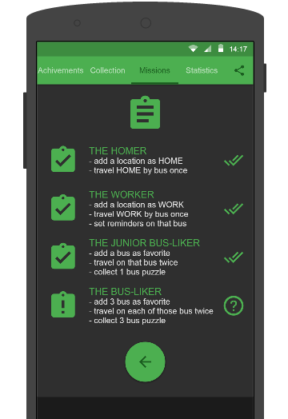

Figure 3.4: View Missions

|  |  |  |  |  |
| --- | --- | --- | --- | --- |
| **UC012 – View missions** | | | | |
| **Use-case No.** | <UC012> | **Use-case Version** | | <1.0> |
| **Use-case Name** | View missions | | | |
| **Author** | Anh TT | | | |
| **Date** | 29/05/2015 | **Priority** | <High > | |
| **Actor:**  User  **Summary:**  When User want to view missions  **Triggers**  User click on missions to view  **Preconditions:**   * User’ phone must have internet * User must be login to the app   **Post Conditions:**  missions screen will be displayed.  **Main Success Scenario:**   |  |  |  | | --- | --- | --- | | **Step** | **Use** | **System** | | 1 | Enter website link on webbrowser | Be displayed Homepage screen | | 2 | Enter necessary and mandatory information and click "Login” | Redirect to previous page and logged user into system. | | 3 | Click on “Liên hệ”->”Đóng góp ý kiến” tab | Be displayed “Đóng góp ý kiến” page | | 4 | Enter information that member want to contribute for the website then click “Đóng góp” | System will receive contributions |   **Alternative Scenario:**   |  |  |  | | --- | --- | --- | | **At Step** | **User** | **System** | | 4 | Enter necessary and mandatory information and click another link | Switch to selected page |   **Exceptions:**   |  |  |  | | --- | --- | --- | | **At Step** | **User** | **System** | | 4 | Missing “Nhập email” field and click “Đóng góp” button | Be displayed error message beside “Nhập email” field. | | 4 | Missing “Nhập nội dung:” field and click “Đóng góp” button | Be displayed error message beside “Nhập nội dung:” field. | | 4 | Enter incorrect information or missing “Mã xác nhận” field and click “Đóng góp” button | Be displayed error message beside “Mã xác nhận” field. | | | | | |

##### UC017: Share title

|  |  |  |  |  |
| --- | --- | --- | --- | --- |
| **UC013 – Share Title** | | | | |
| **Use-case No.** | <UC013> | **Use-case Version** | | <1.0> |
| **Use-case Name** | Share title | | | |
| **Author** | Anh TT | | | |
| **Date** | 29/05/2015 | **Priority** | <High > | |
| **Actor:**  User  **Summary:**  When user want to share their title  **Triggers**  Click on Share symbol.  **Preconditions:**  User’ phone must have internet  User must be login to the app  **Post Conditions:**  Title will be shared.  **Main Success Scenario:**   |  |  |  | | --- | --- | --- | | **Step** | **User** | **System** | | 1 | Enter website link on web browser | Be displayed Homepage screen | | 2 | Enter necessary and mandatory information and click "Login” | Redirect to previous page and logged user into system. | | 3 | Click on “Q&A” tab | Be displayed “Q&A” page | | 4 | Enter necessary and mandatory information in the “Q&A” form and click "Gửi" button. | Be displayed this Q&A in the “Q&A”section. |     **Alternative Scenario:**   |  |  |  | | --- | --- | --- | | **At Step** | **User** | **System** | | 4 | Enter necessary and mandatory information and click another link | Switch to selected page |   **Exceptions:**   |  |  |  | | --- | --- | --- | | **At Step** | **User** | **System** | | 4 | Missing “Nhập email” field and click “Đóng góp” button | Be displayed error message beside “Nhập email” field. | | 4 | Missing “Q&A” field and click “Đóng góp” button | Be displayed error message beside “Q&A” field. | | 4 | Enter incorrect information or missing “Mã xác nhận” field and click “Đóng góp” button | Be displayed error message beside “Mã xác nhận” field. | | | | | |
|  | | | | |

##### UC018: View Statistics

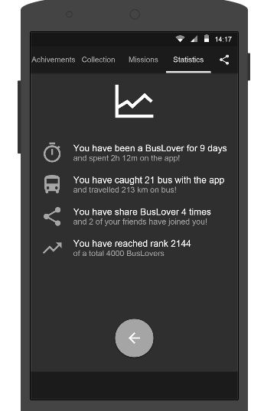

Figure 3.5: View Statistics

|  |  |  |  |  |
| --- | --- | --- | --- | --- |
| **UC012 – View statistics** | | | | |
| **Use-case No.** | <UC012> | **Use-case Version** | | <1.0> |
| **Use-case Name** | View statistics | | | |
| **Author** | Anh TT | | | |
| **Date** | 29/05/2015 | **Priority** | <High > | |
| **Actor:**  User  **Summary:**  When User want to view statistics  **Triggers**  User click on statistics to view  **Preconditions:**   * User’ phone must have internet * User must be login to the app   **Post Conditions:**  statistics screen will be displayed.  **Main Success Scenario:**   |  |  |  | | --- | --- | --- | | **Step** | **Use** | **System** | | 1 | Enter website link on webbrowser | Be displayed Homepage screen | | 2 | Enter necessary and mandatory information and click "Login” | Redirect to previous page and logged user into system. | | 3 | Click on “Liên hệ”->”Đóng góp ý kiến” tab | Be displayed “Đóng góp ý kiến” page | | 4 | Enter information that member want to contribute for the website then click “Đóng góp” | System will receive contributions |   **Alternative Scenario:**   |  |  |  | | --- | --- | --- | | **At Step** | **User** | **System** | | 4 | Enter necessary and mandatory information and click another link | Switch to selected page |   **Exceptions:**   |  |  |  | | --- | --- | --- | | **At Step** | **User** | **System** | | 4 | Missing “Nhập email” field and click “Đóng góp” button | Be displayed error message beside “Nhập email” field. | | 4 | Missing “Nhập nội dung:” field and click “Đóng góp” button | Be displayed error message beside “Nhập nội dung:” field. | | 4 | Enter incorrect information or missing “Mã xác nhận” field and click “Đóng góp” button | Be displayed error message beside “Mã xác nhận” field. | | | | | |

##### UC019: Scan QR code

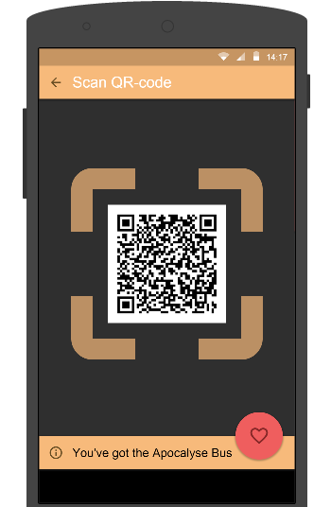

Figure 3.6: Scan QR code

|  |  |  |  |  |
| --- | --- | --- | --- | --- |
| **UC012 – Scan QR code** | | | | |
| **Use-case No.** | <UC012> | **Use-case Version** | | <1.0> |
| **Use-case Name** | Scan QR code | | | |
| **Author** | Anh TT | | | |
| **Date** | 29/05/2015 | **Priority** | <High > | |
| **Actor:**  User  **Summary:**  When User want to scan QR code  **Triggers**  User click on Scan QR code to scan  **Preconditions:**   * User’ phone must have internet * User must be login to the app   **Post Conditions:**  QR code will be scaned.  **Main Success Scenario:**   |  |  |  | | --- | --- | --- | | **Step** | **Use** | **System** | | 1 | Enter website link on webbrowser | Be displayed Homepage screen | | 2 | Enter necessary and mandatory information and click "Login” | Redirect to previous page and logged user into system. | | 3 | Click on “Liên hệ”->”Đóng góp ý kiến” tab | Be displayed “Đóng góp ý kiến” page | | 4 | Enter information that member want to contribute for the website then click “Đóng góp” | System will receive contributions |   **Alternative Scenario:**   |  |  |  | | --- | --- | --- | | **At Step** | **User** | **System** | | 4 | Enter necessary and mandatory information and click another link | Switch to selected page |   **Exceptions:**   |  |  |  | | --- | --- | --- | | **At Step** | **User** | **System** | | 4 | Missing “Nhập email” field and click “Đóng góp” button | Be displayed error message beside “Nhập email” field. | | 4 | Missing “Nhập nội dung:” field and click “Đóng góp” button | Be displayed error message beside “Nhập nội dung:” field. | | 4 | Enter incorrect information or missing “Mã xác nhận” field and click “Đóng góp” button | Be displayed error message beside “Mã xác nhận” field. | | | | | |

### Notification Module

#### Use case diagram

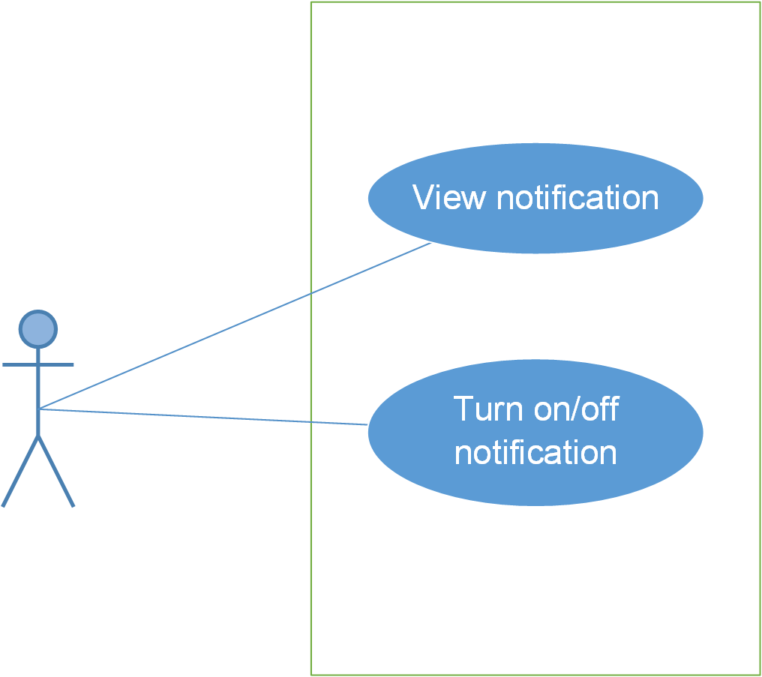

#### Use case specification

##### UC014: View notification

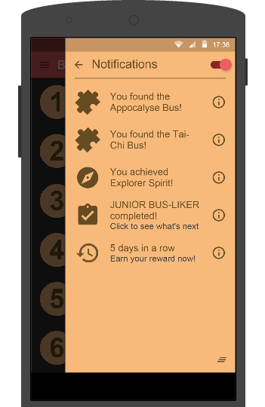

Figure 4.1: View notification

|  |  |  |  |  |
| --- | --- | --- | --- | --- |
| **UC014 – View notification** | | | | |
| **Use-case No.** | <UC014> | **Use-case Version** | | <1.0> |
| **Use-case Name** | View notification | | | |
| **Author** | Anh TT | | | |
| **Date** | 29/05/2015 | **Priority** | <High > | |
| **Actor:**  User  **Summary:**  This function will help users view notification.  **Triggers**  User going to the app, login and then click on “”.  **Preconditions:**  User’ phone must have internet  User must be login to the app  **Post Conditions:**  Notification’s screen will be displayed.  **Main Success Scenario:**   |  |  |  | | --- | --- | --- | | **Step** | **User** | **System** | | 1 | Enter website link on web browser | Be displayed Homepage screen | | 2 | Enter necessary and mandatory information and click "Login” | Redirect to previous page and logged user into system. | | 3 | Click on “Kiểm tra” section | Be displayed “Kiểm tra” page | | 4 | Choose one of items that you want to doing test | Be displayed that item’s page | | 5 | Doing test | Check the answer, grading after finish |     **Alternative Scenario:**   |  |  |  | | --- | --- | --- | | **At Step** | **User** | **System** | | 5 | While doing test, click another link | Switch to selected page | | | | | |

##### UC015: Turn on/off notification

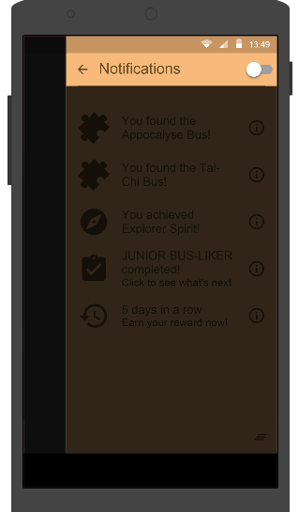

Figure 4.2: Turn off notification

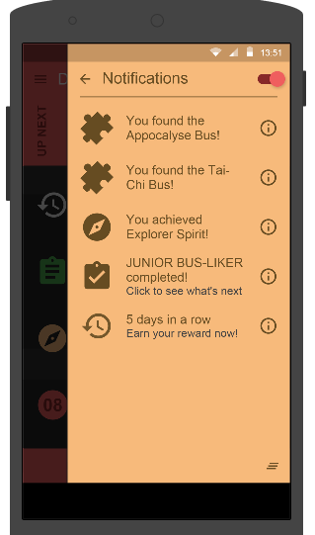

Figure 4.2.1: Turn on notification

|  |  |  |  |  |
| --- | --- | --- | --- | --- |
| **UC015 – Turn on/off notification** | | | | |
| **Use-case No.** | <UC015> | **Use-case Version** | | <1.0> |
| **Use-case Name** | Turn on/off notification | | | |
| **Author** | Anh TT | | | |
| **Date** | 29/05/2015 | **Priority** | <High > | |
| **Actor:**  User  **Summary:**  This function help user turn on or turn off their notification.  **Triggers**  User going to the app and click on Notification button ()  **Preconditions:**  User’ phone must have internet  **Post Conditions:**  The notification will turn off/on  **Main Success Scenario:**   |  |  |  | | --- | --- | --- | | **Step** | **User** | **System** | | 1 | Enter website link on web browser | Be displayed Homepage screen | | 2 | Click on “Luyện nghe” section | Be displayed “Luyện nghe” page |     **Alternative Scenario:**   |  |  |  | | --- | --- | --- | | **At Stp** | **User** | **System** | | 4 | While listening, click another link | Switch to selected page | | | | | |

### Common module

#### Use case diagram

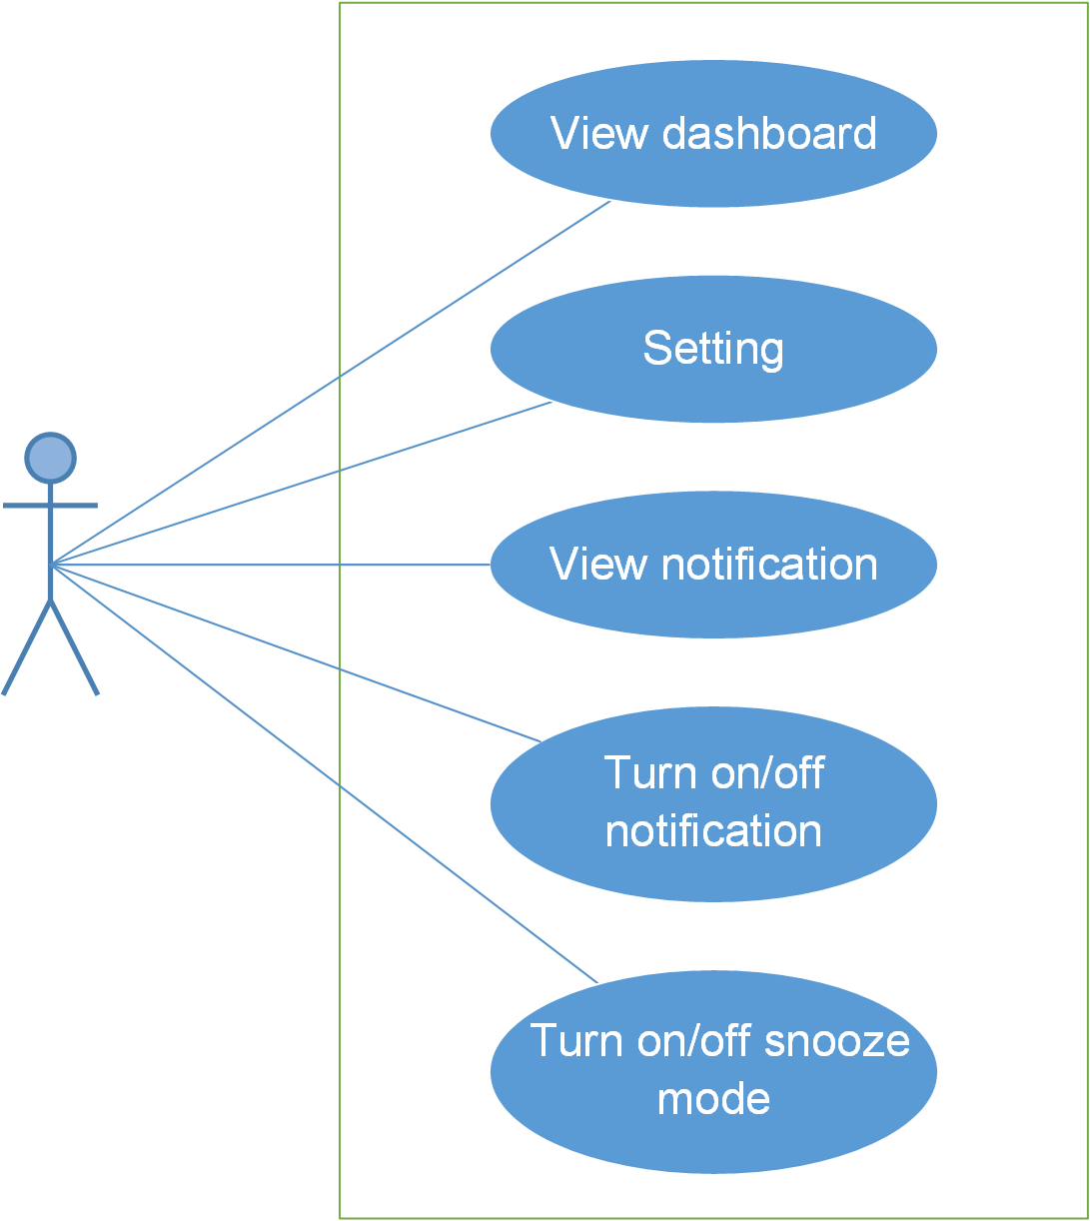

#### Use case specifications

##### UC018: Turn on/off snooze mode

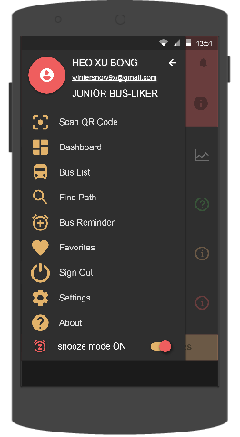

Figure 5.1: Turn on snooze mode

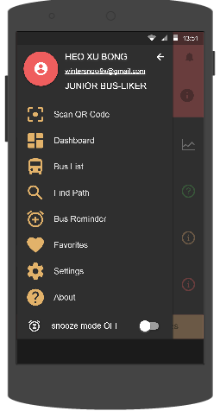

Figure 5.1: Turn off snooze mode

|  |  |  |  |  |  |  |
| --- | --- | --- | --- | --- | --- | --- |
| **No** | **Field name** | **Type** | **Require** | **Mandatory** | **Max-Length** | **Description** |
| 1 | Snooze mode | Switch | Click | Y |  | Admin click to change status of switch. |

Table 5.1: Turn on/off s screen description

|  |  |  |  |  |
| --- | --- | --- | --- | --- |
| **UC018 – Turn on/off snooze mode** | | | | |
| **Use-case No.** | <UC018> | **Use-case Version** | | <1.0> |
| **Use-case Name** | Turn on/off snooze mode | | | |
| **Author** | Anh TT | | | |
| **Date** | 29/05/2015 | **Priority** | <High > | |
| **Actor:**  User  **Summary:**  User can turn on or turn off snooze mode  **Triggers**  User login to the app and click on Snooze mode (  )  **Preconditions:**  User’ phone must have internet  User login to the website  **Post Conditions:**  All of reminder and notification will turn off/on.  **Main Success Scenario:**   |  |  |  | | --- | --- | --- | | **Step** | **User** | **System** | | 1 | Enter website link on web browser | Be displayed Homepage screen | | 2 | Enter necessary and mandatory information and click "Login” | Redirect to previous page and logged admin into system. | | 3 | Click on add new admin button | Be displayed “Add New Admin” screen that contains these elements:   * Username * Password * Roll * Email | | 4 | Fill test information into all necessary or mandatory fields and click “Add” button | The system validates the input data and then save new test data into database |     **Alternative Scenario:**   |  |  |  | | --- | --- | --- | | **At Step** | **User** | **System** | | 4 | Input data in account area then click on another link | Switch to selected page |   **Exceptions:**   |  |  |  | | --- | --- | --- | | **At Step** | **User** | **System** | | 4 | Fill incorrect account name | Return Error message | | | | | |

##### UC019: Setting

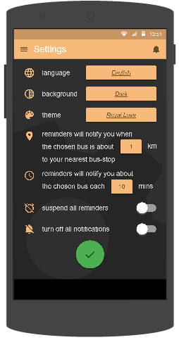

Figure 5.2: Setting

|  |  |  |  |  |  |  |
| --- | --- | --- | --- | --- | --- | --- |
| **No** | **Field name** | **Type** | **Require** | **Mandatory** | **Max-Length** | **Description** |
| 1 | Language | Dropbox | Text | N |  | User choose the language |
| 2 | Background | Text | Text | N |  | User choose the background |
| 3 | Theme | Text | Text | N |  | User choose their theme what they want. |
| 4 | Suspend all reminder | Switch | Click | N |  | User click on/off Switch to turn off all reminder |
| 5 | Turn on/off all notification | Switch | Click | N |  | User click on/off Switch to turn off all notification |

Table 5.2: Setting’s screen description

|  |  |  |  |  |
| --- | --- | --- | --- | --- |
| **UC019 – Setting** | | | | |
| **Use-case No.** | <UC019> | **Use-case Version** | | <1.0> |
| **Use-case Name** | Setting | | | |
| **Author** | Anh TT | | | |
| **Date** | 29/05/2015 | **Priority** | <High > | |
| **Actor:**  User  **Summary:**  User want to setting their app  **Triggers**  User login the app and click on the setting link  **Preconditions:**  User’ phone must have internet  User login the website  **Post Conditions:**  **Main Success Scenario:**   |  |  |  | | --- | --- | --- | | **Step** | **User** | **System** | | 1 | Enter website link on web browser | Be displayed Homepage screen | | 2 | Enter necessary and mandatory information and click "Login” | Redirect to previous page and logged admin into system. | | 3 | Click on edit profile tab | Be displayed “Edit profile” screen that contains these elements:   * Username * Password * New-Password * Renew-Password * Full name * Email | | 4 | Fill test information into all necessary or mandatory fields and click “Add” button | The system validates the input data and then save new test data into database |   **Alternative Scenario:**   |  |  |  | | --- | --- | --- | | **At Step** | **User** | **System** | | 4 | Enter necessary and mandatory information and click another link | Switch to selected page |   **Exceptions:**   |  |  |  | | --- | --- | --- | | **At Step** | **User** | **System** | | 4 | Enter new password that incorrect form or missing information and click “Lưu” button | Be displayed error message | | 4 | Enter new email that incorrect form or missing information and click “Lưu” button | Be displayed error message | | | | | |

##### UC020: View Dashboard

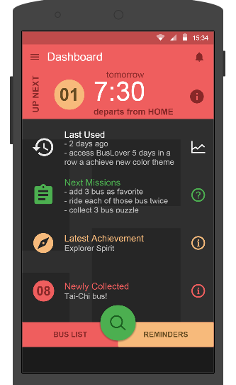

Figure 5.3: View Dashboard

|  |  |  |  |  |
| --- | --- | --- | --- | --- |
| **UC020 – View Dashboard** | | | | |
| **Use-case No.** | <UC020> | **Use-case Version** | | <1.0> |
| **Use-case Name** | View Dashboard | | | |
| **Author** | Anh TT | | | |
| **Date** | 29/05/2015 | **Priority** | <High > | |
| **Actor:**  User  **Summary:**  User can view Dashboard screen.  **Triggers**  User login to the app and click on Dashboard to view.  **Preconditions:**  User’ phone must have internet  User login to the app  **Post Conditions:**  Dashboard’ s screen will be displayed.  **Main Success Scenario:**   |  |  |  | | --- | --- | --- | | **Step** | **User** | **System** | | 1 | Enter website link on web browser | Be displayed Homepage screen | | 2 | Enter necessary and mandatory information and click "Login” | Redirect to previous page and logged admin into system. | | 3 | Click on delete admin link. | Be displayed delete admin page | | 4 | Enter the account that you want to remove administrator rights | Remove administrator rights of account and be displayed message to remove successfully |     **Alternative Scenario:**   |  |  |  | | --- | --- | --- | | **At Step** | **User** | **System** | | 4 | Input data in account area then click on another link | Switch to selected page |   **Exceptions:**   |  |  |  | | --- | --- | --- | | **At Step** | **User** | **System** | | 4 | Fill incorrect account name | Return Error message | | | | | |

##### UC021: View notification



Figure 4.1: View notification

|  |  |  |  |  |
| --- | --- | --- | --- | --- |
| **UC014 – View notification** | | | | |
| **Use-case No.** | <UC014> | **Use-case Version** | | <1.0> |
| **Use-case Name** | View notification | | | |
| **Author** | Anh TT | | | |
| **Date** | 29/05/2015 | **Priority** | <High > | |
| **Actor:**  User  **Summary:**  This function will help users view notification.  **Triggers**  User going to the app, login and then click on “”.  **Preconditions:**  User’ phone must have internet  User must be login to the app  **Post Conditions:**  Notification’s screen will be displayed.  **Main Success Scenario:**   |  |  |  | | --- | --- | --- | | **Step** | **User** | **System** | | 1 | Enter website link on web browser | Be displayed Homepage screen | | 2 | Enter necessary and mandatory information and click "Login” | Redirect to previous page and logged user into system. | | 3 | Click on “Kiểm tra” section | Be displayed “Kiểm tra” page | | 4 | Choose one of items that you want to doing test | Be displayed that item’s page | | 5 | Doing test | Check the answer, grading after finish |     **Alternative Scenario:**   |  |  |  | | --- | --- | --- | | **At Step** | **User** | **System** | | 5 | While doing test, click another link | Switch to selected page | | | | | |

##### UC022: Change app setting

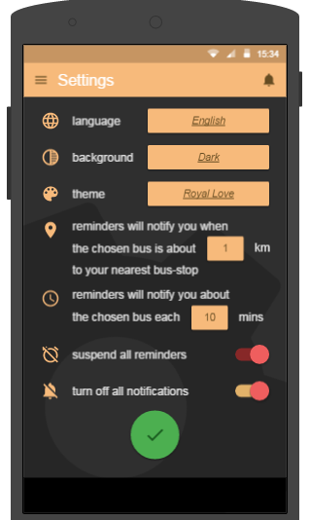

Figure 4.1: Change app setting

|  |  |  |  |  |
| --- | --- | --- | --- | --- |
| **UC014 – Change app setting** | | | | |
| **Use-case No.** | <UC014> | **Use-case Version** | | <1.0> |
| **Use-case Name** | Change app setting | | | |
| **Author** | Anh TT | | | |
| **Date** | 29/05/2015 | **Priority** | <High > | |
| **Actor:**  User  **Summary:**  This function will help users change app’s setting..  **Triggers**  User going to the app, login and then click on setting to change.  **Preconditions:**  User’ phone must have internet  User must be login to the app  **Post Conditions:**  Something will be changed if user want to change.  **Main Success Scenario:**   |  |  |  | | --- | --- | --- | | **Step** | **User** | **System** | | 1 | Enter website link on web browser | Be displayed Homepage screen | | 2 | Enter necessary and mandatory information and click "Login” | Redirect to previous page and logged user into system. | | 3 | Click on “Kiểm tra” section | Be displayed “Kiểm tra” page | | 4 | Choose one of items that you want to doing test | Be displayed that item’s page | | 5 | Doing test | Check the answer, grading after finish |     **Alternative Scenario:**   |  |  |  | | --- | --- | --- | | **At Step** | **User** | **System** | | 5 | While doing test, click another link | Switch to selected page | | | | | |

##### UC023: Synchronize user data

### Favorite module

#### Use case diagram

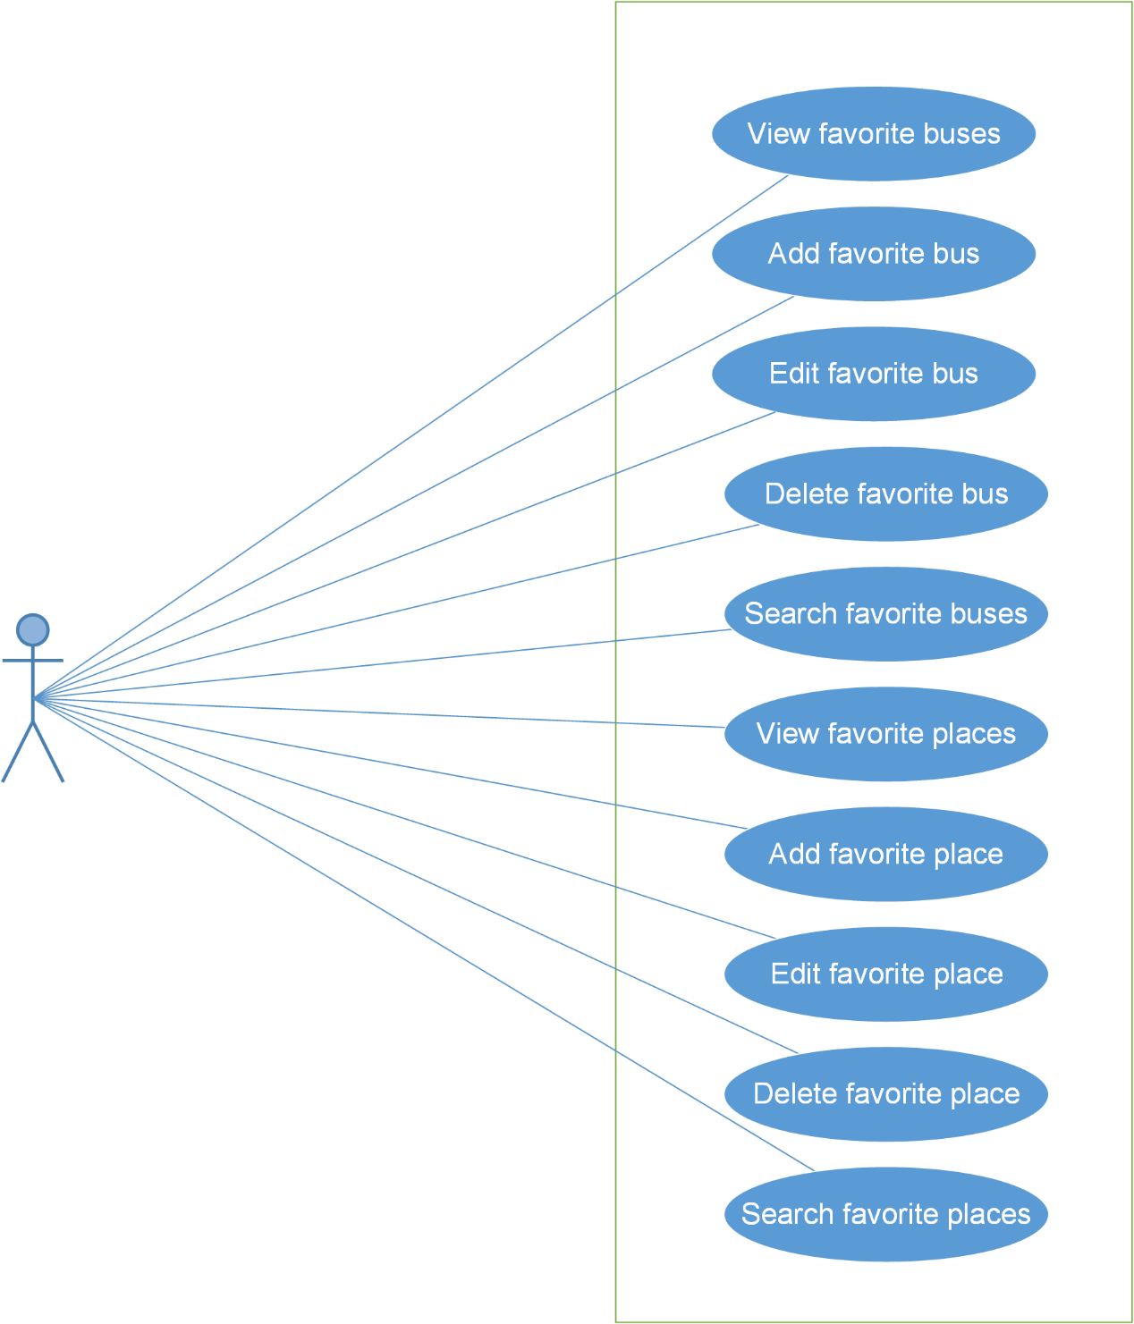

#### Screen description

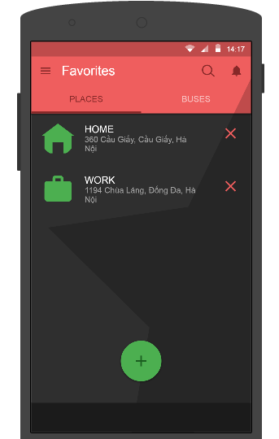

Figure 6: Favorite module

|  |  |  |  |  |  |  |
| --- | --- | --- | --- | --- | --- | --- |
| **No** | **Field name** | **Type** | **Require** | **Mandatory** | **Max-Length** | **Description** |
| 1 | Place | Text | Click | Y |  | List favorite places |
| 2 | Buses | Text | Click | Y |  | List Favorite buses |
| 3 | + | Button | Click | N |  | Add favorite bus |

Table 6: Favorite’s screen description

#### Use case specifications

##### UC021: View favorite places

View favorite places screen:



|  |  |  |  |  |
| --- | --- | --- | --- | --- |
| **UC021 – View favorite places** | | | | |
| **Use-case No.** | <UC021> | **Use-case Version** | | <1.0> |
| **Use-case Name** | View favorite places | | | |
| **Author** | Anh TT | | | |
| **Date** | 29/05/2015 | **Priority** | <High > | |
| **Actor:**  User  **Summary:**  When user want to view favorite places  **Triggers**  On favorites screen, click on PLACES.  **Preconditions:**  User’ phone must have internet  **Post Conditions:**  Be displayed all information of favorite places.  **Main Success Scenario:**   |  |  |  | | --- | --- | --- | | **Step** | **User** | **System** | | 1 | Enter website link on web browser | Be displayed Homepage screen | | 2 | Enter necessary and mandatory information and click "Login” | Redirect to previous page and logged admin into system. | | 3 | Click on "Search member" button and input member’s account or email | Be displayed “member information” screen that contains the information :   * No * User Name * Email * Roll * Ban/Unban * Status * Delete |     **Alternative Scenario:**   |  |  |  | | --- | --- | --- | | **At Step** | **User** | **System** | | 3 | Fill information of the member that they want to find into these fields then click on another link | Switch to selected page |   **Exceptions:**   |  |  |  | | --- | --- | --- | | **At Step** | **User** | **System** | | 3 | Fill information of the member that they want to find (that do not exist in database) into these fields then click “Search” button | Return Error message to inform that member cannot be found | | | | | |

##### UC022: Add favorite places

Add favorite places screen:

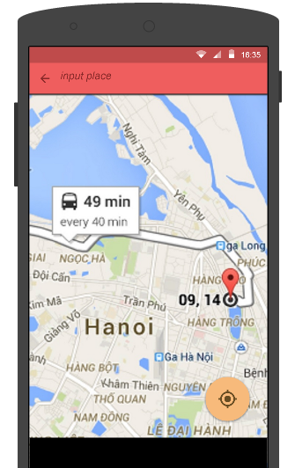

|  |  |  |  |  |
| --- | --- | --- | --- | --- |
| **UC022 – Add favorite places** | | | | |
| **Use-case No.** | <UC022> | **Use-case Version** | | <1.0> |
| **Use-case Name** | Add favorite places | | | |
| **Author** | Anh TT | | | |
| **Date** | 29/05/2015 | **Priority** | <High > | |
| **Actor:**  User  **Summary:**  When user want to add a new favorite place.  **Triggers**  User click on add new favorite button. ( )  **Preconditions:**  User’ phone must have internet  User must be login  **Post Conditions:**  User’s favorite place will be added.  **Main Success Scenario:**   |  |  |  | | --- | --- | --- | | **Step** | **User** | **System** | | 1 | Enter website link on web browser | Be displayed Homepage screen | | 2 | Enter necessary and mandatory information and click "Login” | Redirect to previous page and logged admin into system. | | 3 | Click on "Search member" button and input member’s account or email | Be displayed “member information” screen that contains the information | | 4 | Click “Ban/Unban” link | Ban/Unban member |   **Alternative Scenario:**   |  |  |  | | --- | --- | --- | | **At Step** | **User** | **System** | | 3 | Fill information of the member that they want to find into these fields then click on another link | Switch to selected page |   **Exceptions:**   |  |  |  | | --- | --- | --- | | **At Step** | **User** | **System** | | 3 | Fill information of the member that they want to find (that do not exist in database) into these fields then click “Search” button | Return Error message to inform that member cannot be found | | | | | |

##### UC023: Edit favorite place

|  |  |  |  |  |
| --- | --- | --- | --- | --- |
| **UC023 – Edit favorite place** | | | | |
| **Use-case No.** | <UC023> | **Use-case Version** | | <1.0> |
| **Use-case Name** | Edit favorite place | | | |
| **Author** | Anh TT | | | |
| **Date** | 29/05/2015 | **Priority** | <High > | |
| **Actor:**  User  **Summary:**  User can edit their favorite place  **Triggers**  User will edit their favorite place in Favorites screen.  **Preconditions:**  User’ phone must have internet  User must be login  **Post Conditions:**  User’s favorite place will be edited  **Main Success Scenario:**   |  |  |  | | --- | --- | --- | | **Step** | **User** | **System** | | 1 | Enter website link on web browser | Be displayed Homepage screen | | 2 | Enter necessary and mandatory information and click "Login” | Redirect to previous page and logged admin into system. | | 3 | Click on "Search member" button and input member’s account or email | Be displayed information of member | | 4 | Click on delete link corresponding with member want to delete | Remove member from list |     **Alternative Scenario:**   |  |  |  | | --- | --- | --- | | **At Step** | **User** | **System** | | 3 | Fill information of the member that they want to find into these fields then click on another link | Switch to selected page |   **Exceptions:**   |  |  |  | | --- | --- | --- | | **At Step** | **User** | **System** | | 3 | Fill information of the member that they want to find (that do not exist in database) into these fields then click “Search” button | Return Error message to inform that member cannot be found | | | | | |

##### UC024: Delete favorite place

|  |  |  |  |  |
| --- | --- | --- | --- | --- |
| **UC023 – Delete favorite place** | | | | |
| **Use-case No.** | <UC023> | **Use-case Version** | | <1.0> |
| **Use-case Name** | Delete favorite place | | | |
| **Author** | Anh TT | | | |
| **Date** | 29/05/2015 | **Priority** | <High > | |
| **Actor:**  User  **Summary:**  User can delete their favorite place  **Triggers**  User will delete their favorite place  **Preconditions:**  User’ phone must have internet  User must be login  **Post Conditions:**  User’s favorite place will be deleted  **Main Success Scenario:**   |  |  |  | | --- | --- | --- | | **Step** | **User** | **System** | | 1 | Enter website link on web browser | Be displayed Homepage screen | | 2 | Enter necessary and mandatory information and click "Login” | Redirect to previous page and logged admin into system. | | 3 | Click on "Search member" button and input member’s account or email | Be displayed information of member | | 4 | Click on delete link corresponding with member want to delete | Remove member from list |     **Alternative Scenario:**   |  |  |  | | --- | --- | --- | | **At Step** | **User** | **System** | | 3 | Fill information of the member that they want to find into these fields then click on another link | Switch to selected page |   **Exceptions:**   |  |  |  | | --- | --- | --- | | **At Step** | **User** | **System** | | 3 | Fill information of the member that they want to find (that do not exist in database) into these fields then click “Search” button | Return Error message to inform that member cannot be found | | | | | |

##### UC025: Search favorite place

Search favorite place’s screen:

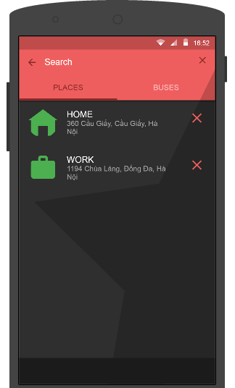

|  |  |  |  |  |
| --- | --- | --- | --- | --- |
| **UC023 – Search favorite place** | | | | |
| **Use-case No.** | <UC023> | **Use-case Version** | | <1.0> |
| **Use-case Name** | Search favorite place | | | |
| **Author** | Anh TT | | | |
| **Date** | 29/05/2015 | **Priority** | <High > | |
| **Actor:**  User  **Summary:**  User can search their favorite place  **Triggers**  User will search their favorite place  **Preconditions:**  User’ phone must have internet  User must be login  **Post Conditions:**  User’s favorite place will be showed if it existed.  **Main Success Scenario:**   |  |  |  | | --- | --- | --- | | **Step** | **User** | **System** | | 1 | Enter website link on web browser | Be displayed Homepage screen | | 2 | Enter necessary and mandatory information and click "Login” | Redirect to previous page and logged admin into system. | | 3 | Click on "Search member" button and input member’s account or email | Be displayed information of member | | 4 | Click on delete link corresponding with member want to delete | Remove member from list |     **Alternative Scenario:**   |  |  |  | | --- | --- | --- | | **At Step** | **User** | **System** | | 3 | Fill information of the member that they want to find into these fields then click on another link | Switch to selected page |   **Exceptions:**   |  |  |  | | --- | --- | --- | | **At Step** | **User** | **System** | | 3 | Fill information of the member that they want to find (that do not exist in database) into these fields then click “Search” button | Return Error message to inform that member cannot be found | | | | | |

##### UC026: View favorite buses

|  |  |  |  |  |
| --- | --- | --- | --- | --- |
| **UC021 – View favorite buses** | | | | |
| **Use-case No.** | <UC021> | **Use-case Version** | | <1.0> |
| **Use-case Name** | View favorite buses | | | |
| **Author** | Anh TT | | | |
| **Date** | 29/05/2015 | **Priority** | <High > | |
| **Actor:**  User  **Summary:**  When user want to view favorite buses  **Triggers**  On favorites screen, click on BUSES.  **Preconditions:**  User’ phone must have internet  **Post Conditions:**  Be displayed all information of favorite buses.  **Main Success Scenario:**   |  |  |  | | --- | --- | --- | | **Step** | **User** | **System** | | 1 | Enter website link on web browser | Be displayed Homepage screen | | 2 | Enter necessary and mandatory information and click "Login” | Redirect to previous page and logged admin into system. | | 3 | Click on "Search member" button and input member’s account or email | Be displayed “member information” screen that contains the information :   * No * User Name * Email * Roll * Ban/Unban * Status * Delete |     **Alternative Scenario:**   |  |  |  | | --- | --- | --- | | **At Step** | **User** | **System** | | 3 | Fill information of the member that they want to find into these fields then click on another link | Switch to selected page |   **Exceptions:**   |  |  |  | | --- | --- | --- | | **At Step** | **User** | **System** | | 3 | Fill information of the member that they want to find (that do not exist in database) into these fields then click “Search” button | Return Error message to inform that member cannot be found | | | | | |

##### UC027: Add favorite buses

|  |  |  |  |  |
| --- | --- | --- | --- | --- |
| **UC022 – Add favorite buses** | | | | |
| **Use-case No.** | <UC022> | **Use-case Version** | | <1.0> |
| **Use-case Name** | Add favorite buses | | | |
| **Author** | Anh TT | | | |
| **Date** | 29/05/2015 | **Priority** | <High > | |
| **Actor:**  User  **Summary:**  When user want to add a new favorite buses.  **Triggers**  User click on add new favorite button.  **Preconditions:**  User’ phone must have internet  User must be login  **Post Conditions:**  User’s favorite buses will be added.  **Main Success Scenario:**   |  |  |  | | --- | --- | --- | | **Step** | **User** | **System** | | 1 | Enter website link on web browser | Be displayed Homepage screen | | 2 | Enter necessary and mandatory information and click "Login” | Redirect to previous page and logged admin into system. | | 3 | Click on "Search member" button and input member’s account or email | Be displayed “member information” screen that contains the information | | 4 | Click “Ban/Unban” link | Ban/Unban member |   **Alternative Scenario:**   |  |  |  | | --- | --- | --- | | **At Step** | **User** | **System** | | 3 | Fill information of the member that they want to find into these fields then click on another link | Switch to selected page |   **Exceptions:**   |  |  |  | | --- | --- | --- | | **At Step** | **User** | **System** | | 3 | Fill information of the member that they want to find (that do not exist in database) into these fields then click “Search” button | Return Error message to inform that member cannot be found | | | | | |

##### UC028: Edit favorite buses

|  |  |  |  |  |
| --- | --- | --- | --- | --- |
| **UC023 – Edit favorite buses** | | | | |
| **Use-case No.** | <UC023> | **Use-case Version** | | <1.0> |
| **Use-case Name** | Edit favorite buses | | | |
| **Author** | Anh TT | | | |
| **Date** | 29/05/2015 | **Priority** | <High > | |
| **Actor:**  User  **Summary:**  User can edit their favorite buses  **Triggers**  User will edit their favorite buses in Favorites screen.  **Preconditions:**  User’ phone must have internet  User must be login  **Post Conditions:**  User’s favorite buses will be edited if it existed.  **Main Success Scenario:**   |  |  |  | | --- | --- | --- | | **Step** | **User** | **System** | | 1 | Enter website link on web browser | Be displayed Homepage screen | | 2 | Enter necessary and mandatory information and click "Login” | Redirect to previous page and logged admin into system. | | 3 | Click on "Search member" button and input member’s account or email | Be displayed information of member | | 4 | Click on delete link corresponding with member want to delete | Remove member from list |     **Alternative Scenario:**   |  |  |  | | --- | --- | --- | | **At Step** | **User** | **System** | | 3 | Fill information of the member that they want to find into these fields then click on another link | Switch to selected page |   **Exceptions:**   |  |  |  | | --- | --- | --- | | **At Step** | **User** | **System** | | 3 | Fill information of the member that they want to find (that do not exist in database) into these fields then click “Search” button | Return Error message to inform that member cannot be found | | | | | |

##### UC029: Delete favorite buses

|  |  |  |  |  |
| --- | --- | --- | --- | --- |
| **UC023 – Delete favorite buses** | | | | |
| **Use-case No.** | <UC023> | **Use-case Version** | | <1.0> |
| **Use-case Name** | Delete favorite buses | | | |
| **Author** | Anh TT | | | |
| **Date** | 29/05/2015 | **Priority** | <High > | |
| **Actor:**  User  **Summary:**  User can delete their favorite buses  **Triggers**  User will delete their favorite buses  **Preconditions:**  User’ phone must have internet  User must be login  **Post Conditions:**  User’s favorite buses will be deleted  **Main Success Scenario:**   |  |  |  | | --- | --- | --- | | **Step** | **User** | **System** | | 1 | Enter website link on web browser | Be displayed Homepage screen | | 2 | Enter necessary and mandatory information and click "Login” | Redirect to previous page and logged admin into system. | | 3 | Click on "Search member" button and input member’s account or email | Be displayed information of member | | 4 | Click on delete link corresponding with member want to delete | Remove member from list |     **Alternative Scenario:**   |  |  |  | | --- | --- | --- | | **At Step** | **User** | **System** | | 3 | Fill information of the member that they want to find into these fields then click on another link | Switch to selected page |   **Exceptions:**   |  |  |  | | --- | --- | --- | | **At Step** | **User** | **System** | | 3 | Fill information of the member that they want to find (that do not exist in database) into these fields then click “Search” button | Return Error message to inform that member cannot be found | | | | | |

##### UC030: Search favorite buses

|  |  |  |  |  |
| --- | --- | --- | --- | --- |
| **UC023 – Search favorite buses** | | | | |
| **Use-case No.** | <UC023> | **Use-case Version** | | <1.0> |
| **Use-case Name** | Search favorite buses | | | |
| **Author** | Anh TT | | | |
| **Date** | 29/05/2015 | **Priority** | <High > | |
| **Actor:**  User  **Summary:**  User can search their favorite buses  **Triggers**  User will search their favorite buses  **Preconditions:**  User’ phone must have internet  User must be login  **Post Conditions:**  User’s favorite buses will be showed if it existed.  **Main Success Scenario:**   |  |  |  | | --- | --- | --- | | **Step** | **User** | **System** | | 1 | Enter website link on web browser | Be displayed Homepage screen | | 2 | Enter necessary and mandatory information and click "Login” | Redirect to previous page and logged admin into system. | | 3 | Click on "Search member" button and input member’s account or email | Be displayed information of member | | 4 | Click on delete link corresponding with member want to delete | Remove member from list |     **Alternative Scenario:**   |  |  |  | | --- | --- | --- | | **At Step** | **User** | **System** | | 3 | Fill information of the member that they want to find into these fields then click on another link | Switch to selected page |   **Exceptions:**   |  |  |  | | --- | --- | --- | | **At Step** | **User** | **System** | | 3 | Fill information of the member that they want to find (that do not exist in database) into these fields then click “Search” button | Return Error message to inform that member cannot be found | | | | | |

### Bus Module

#### Use Case Diagram

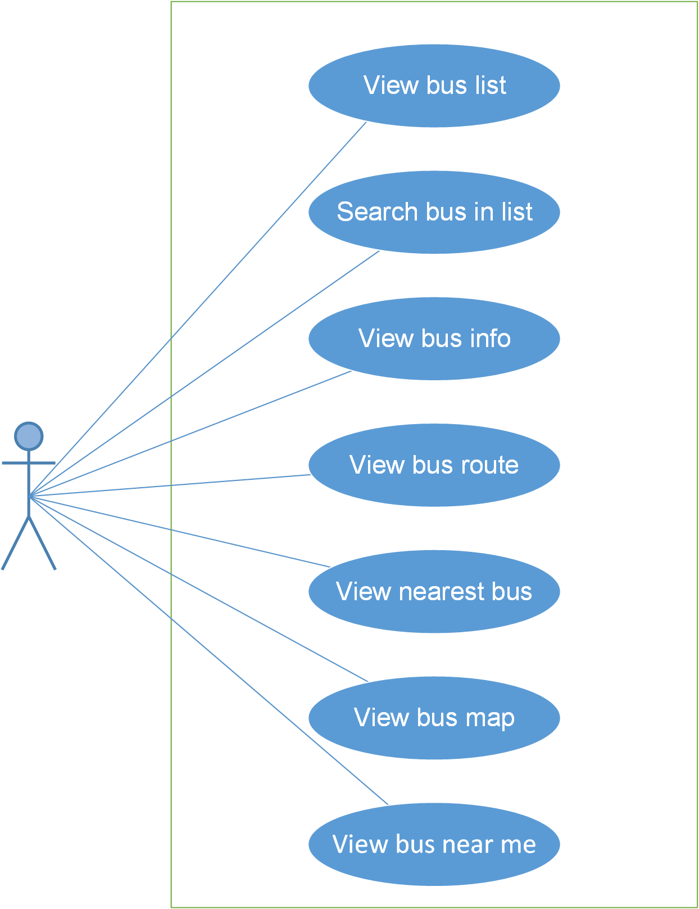

#### Screen description

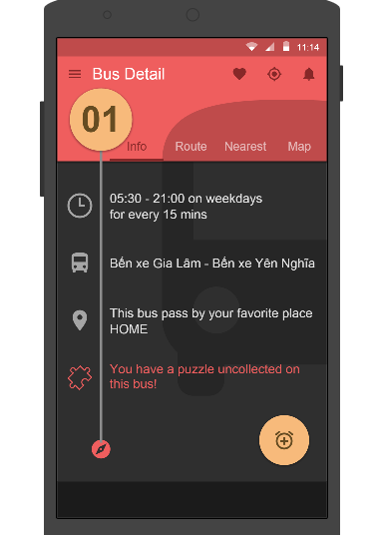

Figure 1: Bus Detail

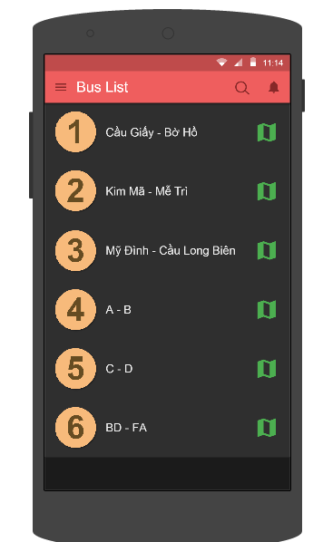

Figure 2: Bus List

|  |  |  |  |  |  |  |  |
| --- | --- | --- | --- | --- | --- | --- | --- |
| **No** | **Field name** | **Field name in Vietnamese** | **Type** | **Require** | **Mandatory** | **Length** | **Description** |
| 1 | ViewBusList | Xem danh sách buýt | Text | Text | Y |  | User click on BusList to view Bus list. |
| 2 | SearchBusInList | Tìm kiếm trong danh sách buýt | Text | Click | Y |  | User click on Search button to search bus in list |
| 3 | ViewBusInfo | Xem thông tin của xe buýt | Text | Click | Y |  | User click on Info to view bus info |
| 4 | View bus route | Xem lộ trình của xe buýt | Text | Click | Y |  | User click on Route to view bus route |
| 5 | View nearest bus | Xem xe buýt gần nhất thuộc tuyến đã chọn | Text | Click | Y |  | User click on Nearest to view nearest bus |
| 6 | View bus map | Xem đường đi của xe buýt trên bản đồ | Text | Click | Y |  | User click on Map to view bus map |
| 7 | View bus near me | Xem tất cả các xe buýt ở gần | Text | Click | Y |  | User click on Bus near me to view bus near they |

Table 1: Search’s screen description

#### Use Case Specification

##### UC001: View bus list

|  |  |  |  |  |
| --- | --- | --- | --- | --- |
| **UC001 – View bus list** | | | | |
| **Use-case No.** | <UC001> | **Use-case Version** | | <1.0> |
| **Use-case Name** | View bus list | | | |
| **Author** | Anh TT | | | |
| **Date** | 28/05/2015 | **Priority** | <High > | |
| **Actor:**  User  **Summary:**  When User want to view bus list  **Triggers**  Click on “Bus list” link.  **Preconditions:**  User’ phone must have internet  User have to login  **Post Conditions:**  Be displayed detail information of bus list  **Main Success Scenario:**   |  |  |  | | --- | --- | --- | | **Step** | **User** | **System** | | 1 | Enter website link on web browser | Be displayed Home page screen | | 2 | Input data in search area and choose “Câu ví dụ” type then click button Search | Be displayed “sentences information” screen that contains the information of chosen sentences with these elements:   * Serial number * Name of sentences by hiragana * Name of sentences by romaji * Meaning of sentences |     **Alternative Scenario:**   |  |  |  | | --- | --- | --- | | **At Step** | **User** | **System** | | 2 | Input data in search area and choose “Câu ví dụ” type then click on another link | Switch to selected page |   **Exceptions:**   |  |  |  | | --- | --- | --- | | **At Step** | **User** | **System** | | 2 | Fill data that they want to find (that do not exist in database) into these fields then click “Search” button | Return Error message to inorm that sentences cannot be found | | | | | |

##### UC002: Search bus in list

|  |  |  |  |  |
| --- | --- | --- | --- | --- |
| **UC002 – Search bus in list** | | | | |
| **Use-case No.** | <UC002> | **Use-case Version** | | <1.0> |
| **Use-case Name** | Search bus in list | | | |
| **Author** | Anh TT | | | |
| **Date** | 28/05/2015 | **Priority** | <High > | |
| **Actor:**  User  **Summary:**  When User want to search bus in bus list  **Triggers**  Click on search button , input bus’ number in the text area, choose type of search and then click “Search” button  **Preconditions:**  User’ phone must have internet  User have to input data in search area  **Post Conditions:**  Be displayed detail information of bus  **Main Success Scenario:**   |  |  |  | | --- | --- | --- | | **Step** | **User** | **System** | | 1 | Enter website link on web browser | Be displayed Home page screen | | 2 | Input data in search area and choose “Hội thoại” type then click button Search | Be displayed “conversation information” screen that contains the information of chosen conversation with these elements:   * Serial number * Name of conversation by hiragana * Name of conversation by romaji * Meaning of conversation |     **Alternative Scenario:**   |  |  |  | | --- | --- | --- | | **At Step** | **User** | **System** | | 2 | Input data in search area and choose “Hội thoại” type then click on another link | Switch to selected page |   **Exceptions:**   |  |  |  | | --- | --- | --- | | **At Step** | **User** | **System** | | 2 | Fill data that they want to find (that do not exist in database) into these fields then click “Search” button | Return Error message to inform that conversation cannot be found | | | | | |

##### UC003: View bus info

|  |  |  |  |  |
| --- | --- | --- | --- | --- |
| **UC003 – View bus info** | | | | |
| **Use-case No.** | <UC003> | **Use-case Version** | | <1.0> |
| **Use-case Name** | View bus info | | | |
| **Author** | Anh TT | | | |
| **Date** | 28/05/2015 | **Priority** | <High > | |
| **Actor:**  User  **Summary:**  When user want to view bus info in database successfully if it is existed  **Triggers**  Click on bus info area, click “Detail” button  **Preconditions:**  User’ phone must have internet  **Post Conditions:**  Be displayed detail information of bus  **Main Success Scenario:**   |  |  |  | | --- | --- | --- | | **Step** | **User** | **System** | | 1 | Enter website link on web browser | Be displayed Home page screen | | 2 | Input data in search area and choose “Ngữ pháp” type then click button Search | Be displayed “grammar information” screen that contains the information of chosen grammar with these elements:   * Serial number * Name of grammar by hiragana * Name of grammar by romaji * Meaning of grammar |     **Alternative Scenario:**   |  |  |  | | --- | --- | --- | | **At Step** | **User** | **System** | | 2 | Input data in search area and choose “Ngữ pháp” type then click on another link | Switch to selected page |   **Exceptions:**   |  |  |  | | --- | --- | --- | | **At Step** | **User** | **System** | | 2 | Fill data that they want to find (that do not exist in database) into these fields then click “Search” button | Return Error message to inform that grammar cannot be found | | | | | |

##### UC004: View bus route

|  |  |  |  |  |
| --- | --- | --- | --- | --- |
| **UC004 – View bus route** | | | | |
| **Use-case No.** | <UC004> | **Use-case Version** | | <1.0> |
| **Use-case Name** | View bus route | | | |
| **Author** | Anh TT | | | |
| **Date** | 28/05/2015 | **Priority** | <High > | |
| **Actor:**  User  **Summary:**  When user want to view bus route in database successfully if it is existed  **Triggers**  Click on bus info area , click “Route” link  **Preconditions:**  User’ phone must have internet  **Post Conditions:**  Be displayed detail information of route  **Main Success Scenario:**   |  |  |  | | --- | --- | --- | | **Step** | **User** | **System** | | 1 | Enter website link on web browser | Be displayed Home page screen | | 2 | Input data in search area and choose “Video” type then click button Search | Be displayed “video information” screen that contains the information of chosen video with these elements:   * Serial number * Name of video by hiragana * Name of video by romaji * Meaning of video |     **Alternative Scenario:**   |  |  |  | | --- | --- | --- | | **At Step** | **User** | **System** | | 2 | Input data in search area and choose “Video” type then click on another link | Switch to selected page |   **Exceptions:**   |  |  |  | | --- | --- | --- | | **At Step** | **User** | **System** | | 2 | Fill data that they want to find (that do not exist in database) into these fields then click “Search” button | Return Error message to inform that video cannot be found | | | | | |

##### UC005: View nearest bus

|  |  |  |  |  |
| --- | --- | --- | --- | --- |
| **UC005 – View nearest bus** | | | | |
| **Use-case No.** | <UC005> | **Use-case Version** | | <1.0> |
| **Use-case Name** | View nearest bus | | | |
| **Author** | Anh TT | | | |
| **Date** | 25/05/2015 | **Priority** | <High > | |
| **Actor:**  User  **Summary:**  When user want to view nearest bus  **Triggers**  Click on bus area, and then click “Nearest” link  **Preconditions:**  User’ phone must have internet  **Post Conditions:**  Be displayed detail information of nearest bus  **Main Success Scenario:**   |  |  |  | | --- | --- | --- | | **Step** | **User** | **System** | | 1 | Enter website link on web browser | Be displayed Home page screen | | 2 | Input data in search area and choose “Tiếng Nhật chuyên ngành” type then click button Search | Be displayed “specialized Japanese information” screen that contains the information of chosen specialized Japanese with these elements:   * Serial number * Name of specialized Japanese by hiragana * Name of specialized Japanese by romaji * Meaning of specialized Japanese |     **Alternative Scenario:**   |  |  |  | | --- | --- | --- | | **At Step** | **User** | **System** | | 2 | Input data in search area and choose “Tiếng Nhật chuyên ngành” type then click on another link | Switch to selected page |   **Exceptions:**   |  |  |  | | --- | --- | --- | | **At Step** | **User** | **System** | | 2 | Fill data that they want to find (that do not exist in database) into these fields then cick “Search” button | Return Error message to inform that specialized Japanese cannot be found | | | | | |

##### UC006: View bus map

|  |  |  |  |  |
| --- | --- | --- | --- | --- |
| **UC005 – View bus map** | | | | |
| **Use-case No.** | <UC005> | **Use-case Version** | | <1.0> |
| **Use-case Name** | View bus map | | | |
| **Author** | Anh TT | | | |
| **Date** | 25/05/2015 | **Priority** | <High > | |
| **Actor:**  User  **Summary:**  When user want to view bus map  **Triggers**  Click on bus area, and then click “Map” link  **Preconditions:**  User’ phone must have internet  **Post Conditions:**  Be displayed detail information of bus map  **Main Success Scenario:**   |  |  |  | | --- | --- | --- | | **Step** | **User** | **System** | | 1 | Enter website link on web browser | Be displayed Home page screen | | 2 | Input data in search area and choose “Tiếng Nhật chuyên ngành” type then click button Search | Be displayed “specialized Japanese information” screen that contains the information of chosen specialized Japanese with these elements:   * Serial number * Name of specialized Japanese by hiragana * Name of specialized Japanese by romaji * Meaning of specialized Japanese |     **Alternative Scenario:**   |  |  |  | | --- | --- | --- | | **At Step** | **User** | **System** | | 2 | Input data in search area and choose “Tiếng Nhật chuyên ngành” type then click on another link | Switch to selected page |   **Exceptions:**   |  |  |  | | --- | --- | --- | | **At Step** | **User** | **System** | | 2 | Fill data that they want to find (that do not exist in database) into these fields then cick “Search” button | Return Error message to inform that specialized Japanese cannot be found | | | | | |

##### UC007: View bus near me

|  |  |  |  |  |
| --- | --- | --- | --- | --- |
| **UC005 – View bus near me** | | | | |
| **Use-case No.** | <UC005> | **Use-case Version** | | <1.0> |
| **Use-case Name** | View bus near me | | | |
| **Author** | Anh TT | | | |
| **Date** | 25/05/2015 | **Priority** | <High > | |
| **Actor:**  User  **Summary:**  When user want to view bus near they  **Triggers**  While in Dashboard screen, click on button “Bus near me”  **Preconditions:**  User’ phone must have internet  **Post Conditions:**  Be displayed detail information of bus near they  **Main Success Scenario:**   |  |  |  | | --- | --- | --- | | **Step** | **User** | **System** | | 1 | Enter website link on web browser | Be displayed Home page screen | | 2 | Input data in search area and choose “Tiếng Nhật chuyên ngành” type then click button Search | Be displayed “specialized Japanese information” screen that contains the information of chosen specialized Japanese with these elements:   * Serial number * Name of specialized Japanese by hiragana * Name of specialized Japanese by romaji * Meaning of specialized Japanese |     **Alternative Scenario:**   |  |  |  | | --- | --- | --- | | **At Step** | **User** | **System** | | 2 | Input data in search area and choose “Tiếng Nhật chuyên ngành” type then click on another link | Switch to selected page |   **Exceptions:**   |  |  |  | | --- | --- | --- | | **At Step** | **User** | **System** | | 2 | Fill data that they want to find (that do not exist in database) into these fields then cick “Search” button | Return Error message to inform that specialized Japanese cannot be found | | | | | |

### Track module

#### Use case diagram

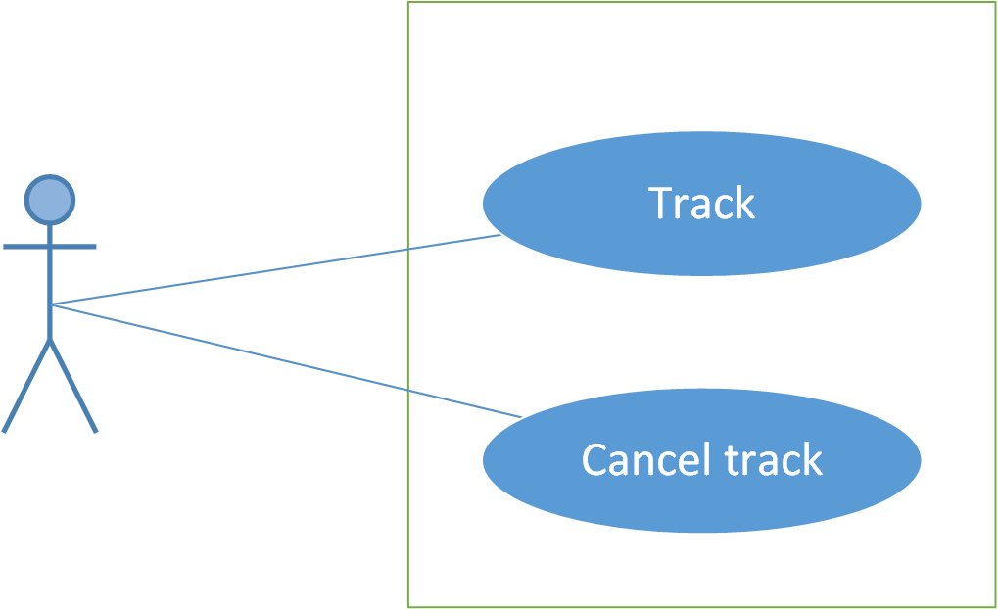

#### Screen description

Figure 7: Vocabulary management

|  |  |  |  |  |  |  |
| --- | --- | --- | --- | --- | --- | --- |
| **No** | **Field name** | **Type** | **Require** | **Mandatory** | **Max-Length** | **Description** |
| 1 | Romaji | Text | Text | Y | 100 | Admin input romaji with length less than 100 character |
| 2 | Search | Button | Click | Y |  | Admin click to search vocabulary |
| 2 | Add-new | Button | Click | N |  | Admin add new vocabulary into database |
| 3 | Add meaning | Button | Click | Y |  | Admin add meaning of vocabulary |
| 4 | Edit | Button | Click | N |  | Admin click edit vocabulary |
| 5 | Delete | Button | Click | N |  | Admin click delete vocabulary |
| 6 | Add-reference | Button | Click | N |  | Admin add reference of vocabulary if reference exist |
| 7 | List-contribute | Button | Click | N |  | Admin click to view list contribute |

Table 7.1: Vocabulary management’s screen description

#### Use case specifications

##### UC024: Set tracker

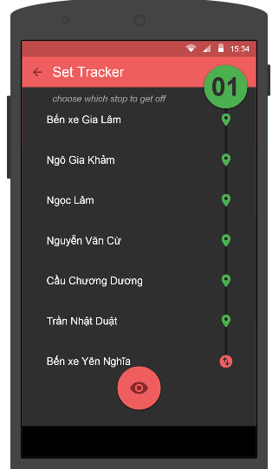

Figure 7.1: Set tracker

|  |  |  |  |  |
| --- | --- | --- | --- | --- |
| **UC0024 – Set tracker** | | | | |
| **Use-case No.** | <UC0024> | **Use-case Version** | | <1.0> |
| **Use-case Name** | Set tracker | | | |
| **Author** | Anh TT | | | |
| **Date** | 29/05/2015 | **Priority** | <High > | |
| **Actor:**  User  **Summary:**  When user want to set their tracker.  **Triggers**  User login to the app and click on Tracker symbol ().  **Preconditions:**  User’ phone must have internet  User must be login  **Post Conditions:**  Tracker will be set if user want to set it.  **Main Success Scenario:**   |  |  |  | | --- | --- | --- | | **Step** | **User** | **System** | | 1 | Enter website link on web browser | Be displayed Homepage screen | | 2 | Enter necessary and mandatory information and click "Login” | Redirect to previous page and logged admin into system. | | 4 | Click on “vocabulary management” tab | Be displayeds criteria search screen | | 5 | Fill information of the vocabulary that they want to find into these fields then click “Search” button | Be displayeds search result as a table with these elements:   * No * Hiragana * Romaji * Status * Meaning * Category * Kanji * Specialized * Add meaning * Edit * Delete * Add reference |     **Alternative Scenario:**   |  |  |  | | --- | --- | --- | | **At Step** | **User** | **System** | | 5 | Fill information of the vocabulary that they want to find into these fields then click on another link | Switch to selected page |   **Exceptions:**   |  |  |  | | --- | --- | --- | | **At Step** | **User** | **System** | | 5 | Fill information of the vocabulary that they want to find (that do not exited in database) into these fields then click “Search” button | Return Error message to inform that vocabulary structure cannot be found | | | | | |

##### UC025: Tracking

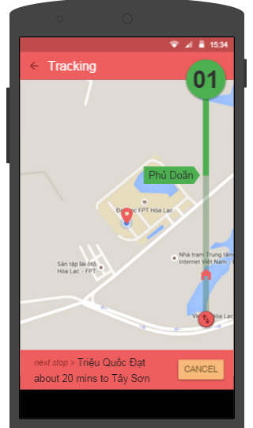

Figure 7.2: Tracking

Figure 7.2.1: Add vocabulary meaning

|  |  |  |  |  |  |  |
| --- | --- | --- | --- | --- | --- | --- |
| **No** | **Field name** | **Type** | **Require** | **Mandatory** | **Max-Length** | **Description** |
| 1 | Cancel | Button | Click | N |  | User click on Cancel button to cancel tracking. |

Table 7.2: Tracking’s screen description

|  |  |  |  |  |
| --- | --- | --- | --- | --- |
| **UC0025 - Tracking** | | | | |
| **Use-case No.** | <UC0025> | **Use-case Version** | | <1.0> |
| **Use-case Name** | Tracking | | | |
| **Author** | Anh TT | | | |
| **Date** | 29/05/2015 | **Priority** | <High > | |
| **Actor:**  User  **Summary:**  When user want to view the next stop place  **Triggers**  User must login to the app, and then go to Bus detail’s screen, click on track’s symbol (  ), then click on “”.  **Preconditions:**  User’ phone must have internet   * User must login to the app.   **Post Conditions:**  Tracking’s screen will be displayed.  **Main Success Scenario:**   |  |  |  | | --- | --- | --- | | **Step** | **User** | **System** | | 1 | Enter website link on web browser | Be displayed Homepage screen | | 2 | Enter necessary and mandatory information and click "Login” | Redirect to previous page and logged admin into system. | | 3 | Click on “Vocabulary management/Add new” tab | Be displayed “Add New Vocabulary” screen that contains these elements:   * Hiragana * Romaji | | 4 | Fill information into all necessary or mandatory fields and click “Add” button | The system validates the input data and then save new vocabulary data into database | | 5 | Click on “Vocabulary management/Add meaning” tab | Be displayed “Add meaning” screen that contains these elements:   * Hiragana * Romaji * Meaning * Category * Kanji * Specialized | | 6 | Fill information into all necessary or mandatory fields and click “Add” button | The system validates the input data and then save new vocabulary data into database | | 7 | Click on “Vocabulary management/Add reference” tab | Be displayed “Add meaning” screen that contains these elements:   * Vocabulary * Meaning * Sentence | | 8 | Choose sentence and click “Add” button | The system validates the input data and then save new vocabulary data into database |     **Alternative Scenario:**   |  |  |  | | --- | --- | --- | | **At Step** | **User** | **System** | | 4 | Click on another link | Do not save new vocabulary data into database then redirect to selected page | | 6 | Click on another link | Do not save meaning data into database then redirect to selected page | | 8 | Click on another link | Do not save reference into database then redirect to selected page |   **Exceptions:**   |  |  |  | | --- | --- | --- | | **At Step** | **User** | **System** | | 4 | Do not fill full information into fields then click “Add” button | Return Error message beside empty field and ask if user want to add with empty field. | | 6 | Do not fill full information into fields then click “Add” button | Return Error message beside empty field and ask if user want to add with empty field. | | 8 | Do not fill full information into fields then click “Add” button | Return Error message beside empty field and ask if user want to add with empty field. | | | | | |

##### UC026: Cancel Tracking



Figure 7.3: Cancel tracking

|  |  |  |  |  |  |  |
| --- | --- | --- | --- | --- | --- | --- |
| **No** | **Field name** | **Type** | **Require** | **Mandatory** | **Max-Length** | **Description** |
| 1 | Cancel | Button | Click | N |  | User click on Cancel button to cancel tracking. |

|  |  |  |  |  |
| --- | --- | --- | --- | --- |
| **UC0026 – Cancel tracking** | | | | |
| **Use-case No.** | <UC0026> | **Use-case Version** | | <1.0> |
| **Use-case Name** | Cancel tracking | | | |
| **Author** | Anh TT | | | |
| **Date** | 29/05/2015 | **Priority** | <High > | |
| **Actor:**  User  **Summary:**  When user want to cancel tracking.  **Triggers**  In Tracking’s screen, user click on Cancel button.  **Preconditions:**  User’ phone must have internet  User must login to the app.  **Post Conditions:**  Tracking will be canceled and come back to the Bus detail’s screen.  **Main Success Scenario:**   |  |  |  | | --- | --- | --- | | **Step** | **User** | **System** | | 1 | Enter website link on web browser | Be displayed Homepage screen | | 2 | Enter necessary and mandatory information and click "Login” | Redirect to previous page and logged admin into system. | | 3 | Click on “Vocabulary management ” then search for the vocabulary that they want to edit | Be displayeds search result as a table | | 4 | Click on “Edit” link | Be displayed “Edit Vocabulary” screen that contains the information of chosen vocabulary with these elements:   * Hiragana * Romaji * Meaning * Category * Kanji * Specialized | | 5 | Edit vocabulary information and click “Edit” button | The system validates the input data and then save data into database |     **Alternative Scenario:**   |  |  |  | | --- | --- | --- | | **At Step** | **User** | **System** | | 4 | Edit vocabulary information then click to another link | Do not save edited data then redirect to selected page |   **Exceptions:**   |  |  |  | | --- | --- | --- | | **At Step** | **User** | **System** | | 4 | Edit vocabulary information to be similar to another existed grammar and click “Edit” button | The system validates the input data and return Error message and do not save edited data into database |   **Reference:**  UC0024 - Search Vocabulary | | | | |

### Path finder module

#### Use case diagram

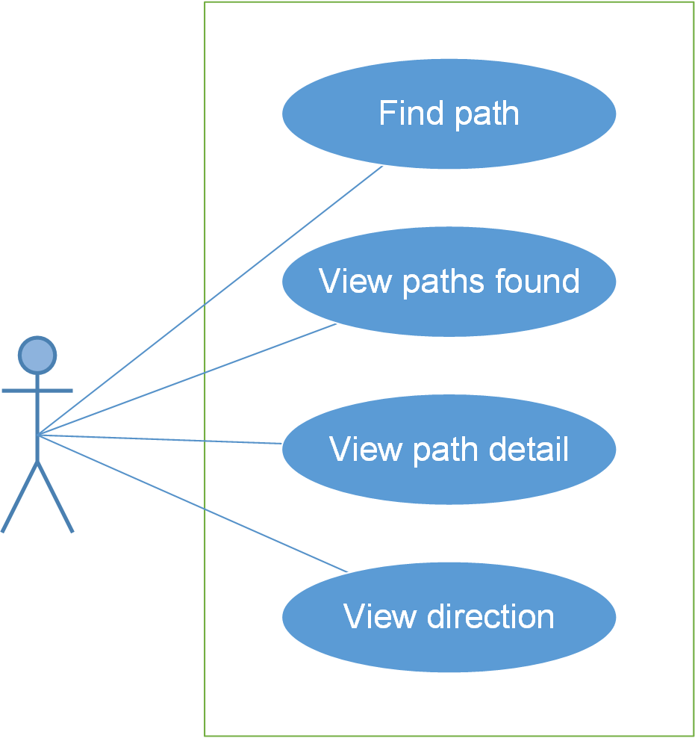

#### Screen description

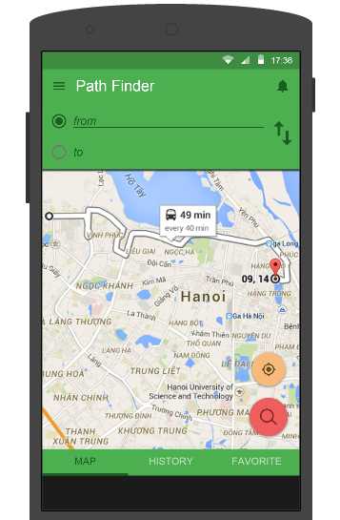

Figure 8: Path finder

|  |  |  |  |  |  |  |
| --- | --- | --- | --- | --- | --- | --- |
| **No** | **Field name** | **Type** | **Require** | **Mandatory** | **Max-Length** | **Description** |
| 1 | From | Text | Text | Y | 100 | User will input the place where they will start by bus. |
| 2 | To | Text | Text | Y | 100 | User will input the place where they will finish by bus. |
| 3 | MAP | Text | Click | N |  | When user click on Map, map will be displayed. |
| 4 | HISTORY | Text | Click | N |  | Click on HISTORY to view history. |
| 5 | FAVORITE | Text | Click | N |  | Click on FAVORITE to view favorite path. |
| 6 |  | Button | Click | Y |  | When user click on this button, the direction will reverse. |
| 7 |  | Button | Click | Y |  | User click on this button to view Path Found. |
| Table 8.1: Path finder’s screen description | | | | | | |

#### Use case specifications

##### UC0028: Find path

Find path’s screen:

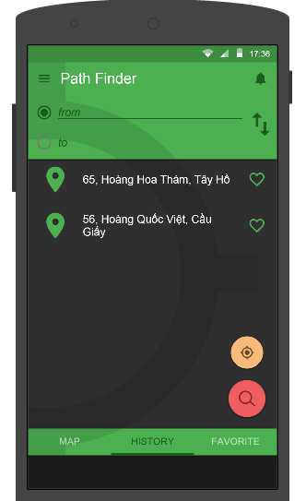

Figure 8.1: Find path

|  |  |  |  |  |
| --- | --- | --- | --- | --- |
| **UC0028 – Find path** | | | | |
| **Use-case No.** | <UC0028> | **Use-case Version** | | <1.0> |
| **Use-case Name** | Find path | | | |
| **Author** | Anh TT | | | |
| **Date** | 29/05/2015 | **Priority** | <High > | |
| **Actor:**  User  **Summary:**  When user want to find one or more path.  **Triggers**  User login and then click on “Find path” button  **Preconditions:**  User’ phone must have internet  User has to login to the app  **Post Conditions:**  Be displayed detail information of grammatical structure  **Main Success Scenario:**   |  |  |  | | --- | --- | --- | | **Step** | **User** | **System** | | 1 | Have logged into system as an admin |  | | 2 | Click on “Grammar management” tab | Be displayeds criteria search screen | | 3 | Fill information of the grammatical structure that they want to find into these fields then click “Search” button | Be displayeds search result as a table with these elements:   * No * Hiragana * Romaji * Level * Meaning * Use * Status * Add reference * Edit * Delete |     **Alternative Scenario:**   |  |  |  | | --- | --- | --- | | **At Step** | **User** | **System** | | 3 | Fill information of the grammatical structure that they want to find into these fields then click on another link | Switch to selected page |   **Exceptions:**   |  |  |  | | --- | --- | --- | | **At Step** | **User** | **System** | | 3 | Fill information of the grammatical structure that they want to find (that do not exited in database) into these fields then click “Search” button | Return Error message to inform that grammatical structure cannot be found | | | | | |

##### UC0029: View path found

Path found’s screen:

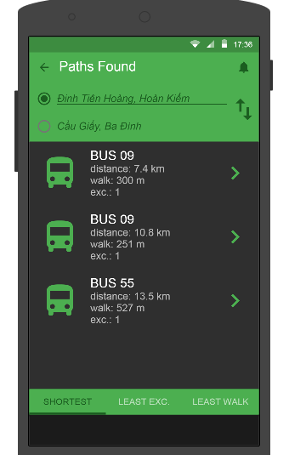

Figure 8.2: Path found

|  |  |  |  |  |
| --- | --- | --- | --- | --- |
| **UC0029 – View path found** | | | | |
| **Use-case No.** | <UC0029> | **Use-case Version** | | <1.0> |
| **Use-case Name** | View Path found | | | |
| **Author** | Anh TT | | | |
| **Date** | 29/05/2015 | **Priority** | <High > | |
| **Actor:**  User  **Summary:**  When user want to view Path found  **Triggers**  User must login to the app, in the Path finder’s screen, user input the place where they want to start and finish place, then click on search button.  **Preconditions:**  User’ phone must have internet  User has to login to the app.  **Post Conditions:**  Path found’s screen will be displayed.  **Main Success Scenario:**   |  |  |  | | --- | --- | --- | | **Step** | **User** | **System** | | 1 | Have logged into system as an admin |  | | 2 | Click on “Grammar management/Add New” | Be displayed “Add Grammar” screen that contains these elements:   * Hiragana * Romaji * Level * Meaning * Use * Lesson | | 3 | Fill grammar information into all necessary or mandatory fields and click “Add” button | The system validates the input data and then save new grammar data into database | | 4 | Click on “Grammar management/Add Reference” | Be displayed “Add Grammar” screen that contains these elements:   * Grammar * Meaning * Reference | | 5 | Fill grammar information into all necessary or mandatory fields and click “Add” button | The system validates the input data and then save new grammar data into database |     **Alternative Scenario:**   |  |  |  | | --- | --- | --- | | **At Step** | **User** | **System** | | 3 | Click on another link | Do not save new grammar data into database then redirect to selected page | | 5 | Click on another link | Do not save new reference data into database then redirect to selected page |   **Exceptions:**   |  |  |  | | --- | --- | --- | | **At Step** | **User** | **System** | | 3 | Do not fill full information into fields then click “Add” button | Return Error message and request user input data into all fields | | 5 | Do not fill full information into fields then click “Add” button | Return Error message and request user input data into all fields | | | | | |

##### UC0030: View path detail

Path detail’s screen:

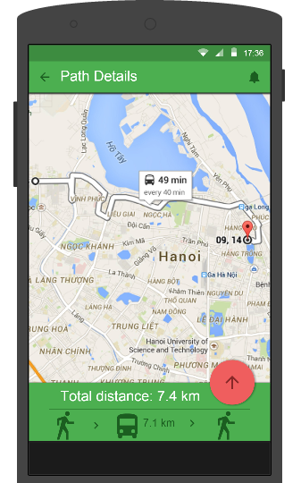

Figure 8.3: Edit grammar

|  |  |  |  |  |
| --- | --- | --- | --- | --- |
| **UC0030 – View path detail** | | | | |
| **Use-case No.** | <UC0030> | **Use-case Version** | | <1.0> |
| **Use-case Name** | View path detail | | | |
| **Author** | Anh TT | | | |
| **Date** | 29/05/2015 | **Priority** | <High > | |
| **Actor:**  User  **Summary:**  When user want to view the path detail  **Triggers**  User must login to the app, in Path found’s screen user click on bus what they want to view detail.  **Preconditions:**  User’ phone must have internet  User has to login to the app  **Post Conditions:**  Path detail’s screen will be displayed.  **Main Success Scenario:**   |  |  |  | | --- | --- | --- | | **Step** | **User** | **System** | | 1 | Have logged into system as an admin |  | | 2 | Click on “Management grammar ” then search for the grammatical structure that they want to edit | Be displayeds search result as a table | | 3 | Click on “Edit” link corresponding with grammar | Be displayed “Edit Grammar” screen that contains the information of chosen grammar with these elements:   * Hiragana * Romaji * Level * Meaning * Use * Lesson | | 4 | Edit grammar information and click “Edit” button | The system validates the input data and then save data into database |     **Alternative Scenario:**   |  |  |  | | --- | --- | --- | | **At Step** | **User** | **System** | | 4 | Edit grammar information then click to another link | Do not save edited data then redirect to selected page |   **Exceptions:**   |  |  |  | | --- | --- | --- | | **At Step** | **User** | **System** | | 4 | Edit grammar information to be similar to another existed grammar and click “Edit” button | The system validates the input data and return Error message and do not save edited data into database |   **Reference:**  UC0028 - <Admin> Search Grammar | | | | |
|  | | | | |

##### UC0031: View direction

Direction’s screen:

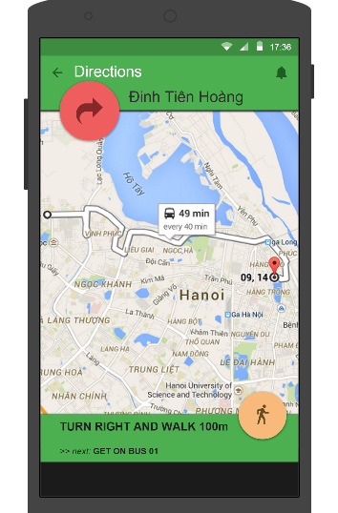

|  |  |  |  |  |
| --- | --- | --- | --- | --- |
| **UC0031 – View direction** | | | | |
| **Use-case No.** | <UC0031> | **Use-case Version** | | <1.0> |
| **Use-case Name** | View direction | | | |
| **Author** | Anh TT | | | |
| **Date** | 29/05/2015 | **Priority** | <High > | |
| **Actor:**  User  **Summary:**  When user want to view direction.  **Triggers**  User must login to the app, in Path detail’s screen, user click on symbol (  ), and then click .  **Preconditions:**  User’ phone must have internet  User has to login to the app  **Post Conditions:**  Direction’s screen will be displayed.  **Main Success Scenario:**   |  |  |  | | --- | --- | --- | | **Step** | **User** | **System** | | 1 | Have logged into system as an admin |  | | 2 | Click on “Grammar management ” then search for the grammar that they want to delete | Be displayeds search result as a table | | 3 | Click on “Delete” link corresponding with grammar | Remove that grammar in database |   **Reference:** UC0028 - <Admin> Search grammar | | | | |
|  | | | | |

### Reminder module

#### Use case diagram

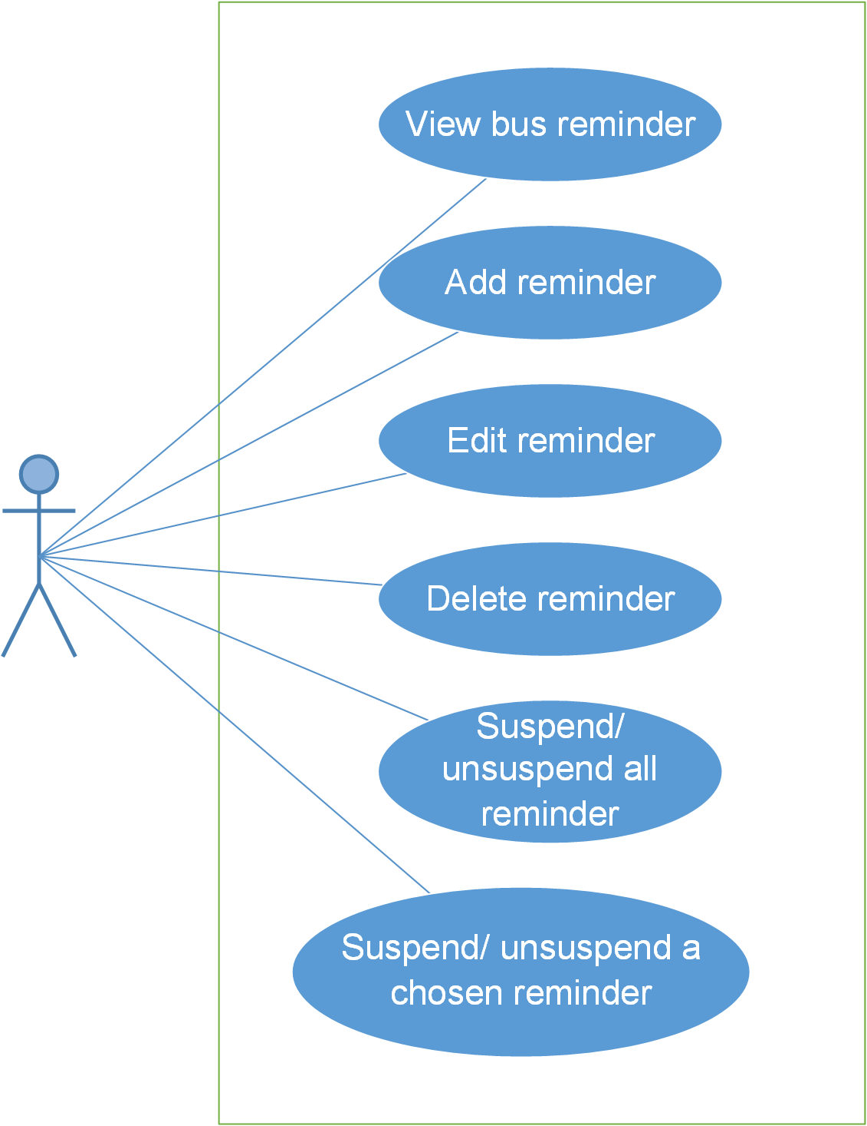

#### Screen description

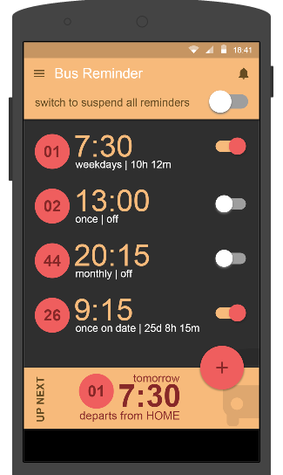

Figure 9: Bus Reminder

#### Use case specifications

##### UC0032: View bus reminder



Figure 9.1: Search reading document

|  |  |  |  |  |
| --- | --- | --- | --- | --- |
| **UC0032 – View bus reminder** | | | | |
| **Use-case No.** | <UC0032> | **Use-case Version** | | <1.0> |
| **Use-case Name** | View bus reminder | | | |
| **Author** | Anh TT | | | |
| **Date** | 29/05/2015 | **Priority** | <High > | |
| **Actor:**  User  **Summary:**  When user want to view bus reminder.  **Triggers**  User click on Reminder on Dashboard screen to view Bus reminder  **Preconditions:**  User has to login to the app.  User’ phone must have internet  **Post Conditions:**  Bus reminder‘s screen will be displayed  **Main Success Scenario:**   |  |  |  | | --- | --- | --- | | **Step** | **User** | **System** | | 1 | Have logged into system as an admin |  | | 2 | Click on “Reading management” tab | Be displayeds criteria search screen | | 3 | Choose level of the reading document that they want to find then click “Search” button | Be displayeds search result as a table with these elements:   * No * Title * Code * Level * Vocabulary * Article * Edit * Delete |     **Alternative Scenario:**   |  |  |  | | --- | --- | --- | | **At Step** | **User** | **System** | | 3 | Choose level of the reading document that they want to find into these fields then click on another link | Switch to selected page |   **Exceptions:**   |  |  |  | | --- | --- | --- | | **At Step** | **User** | **System** | | 3 | Choose level of the reading document that they want to find (that do not exited in database) into these fields then click “Search” button | Return Error message to inform that reading document cannot be found | | | | | |
|  | | | | |

##### UC0033: Add reminder

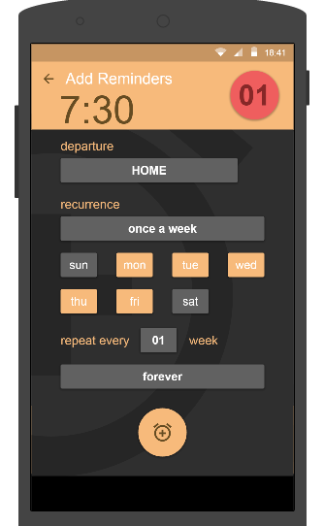

Figure 9.2: Add reminder

|  |  |  |  |  |  |  |
| --- | --- | --- | --- | --- | --- | --- |
| **No** | **Field name** | **Type** | **Require** | **Mandatory** | **Max-Length** | **Description** |
| 1 | Departure | Text | Text | Y | 100 | User input information with length less than 100 character |
| 2 | Recurrence | Drop-down list | Click | Y |  | User input time to remind. |
| 3 | Forever | Button | Click | Y |  | User choose type of remind. |

Table 9.2: Add reminder’s screen description

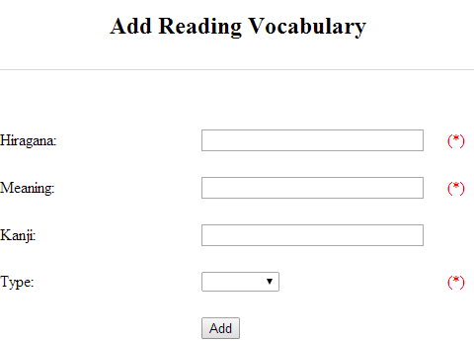

Figure 9.2.1: Add reading vocabulary

|  |  |  |  |  |  |  |
| --- | --- | --- | --- | --- | --- | --- |
| **No** | **Field name** | **Type** | **Require** | **Mandatory** | **Max-Length** | **Description** |
| 1 | Hiragana | Text | Text | Y | 100 | Admin input hiragana with length less than 100 character |
| 2 | Meaning | Text | Text | Y | 100 | Admin input meaning with length less than 100 characters |
| 3 | Kanji | Text | Text | N | 10 | Admin input kanji with length less than 10 characters |
| 4 | Type | Drop-down list | Click | Y |  | Admin choose the type |
| 5 | Add | Button | Click | Y |  | Admin click to add reading vocabulary |

Table 9.2.1: Add reading vocabulary’s screen description

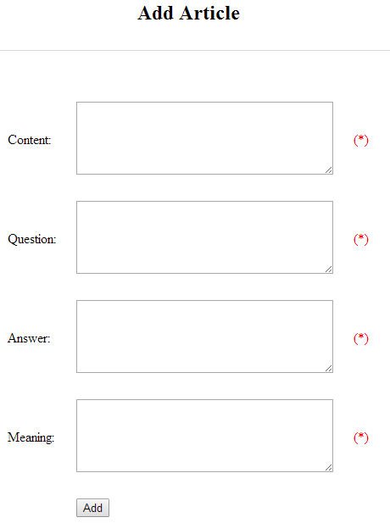

Figure 9.2.2: Add article

|  |  |  |  |  |  |  |
| --- | --- | --- | --- | --- | --- | --- |
| **No** | **Field name** | **Type** | **Require** | **Mandatory** | **Max-Length** | **Description** |
| 1 | Content | Text | Text | Y | 5000 | Admin input content with length less than 5000 character |
| 2 | Question | Text | Text | Y | 5000 | Admin input question with length less than 5000 characters |
| 3 | Answer | Text | Text | Y | 5000 | Admin input answer with length less than 5000 characters |
| 4 | Meaning | Text | Text | Y | 5000 | Admin input meaning with length less than 5000 characters |
| 5 | Add | Button | Click | Y |  | Admin click to add article |

Table 9.2.2: Add article’s screen description

|  |  |  |  |  |
| --- | --- | --- | --- | --- |
| **UC0030 - Specification** | | | | |
| **Use-case No.** | <UC0030> | **Use-case Version** | | <1.0> |
| **Use-case Name** | Add document | | | |
| **Author** | Anh TT | | | |
| **Date** | 29/05/2015 | **Priority** | <High > | |
| **Actor:**  Admin  **Summary:**  When Administrator want to add new reading document into database. They have to insert all necessary data of reading document into “Add new reading” screen  **Triggers**  User must click on “Reading management/ Add new” tab and input all necessary information of grammar into the right fields then click on “Add new” button  **Preconditions:**   * User have logged into system as an admin. * All mandatory fields have been filled * All input data must be valid and have not existed in system   **Post Conditions:**  New reading document has been saved into system database successfully  **Main Success Scenario:**   |  |  |  | | --- | --- | --- | | **Step** | **User** | **System** | | 1 | Have logged into system as an admin |  | | 2 | Click on “Reading management/Add new” tab | Be displayed “Add New Reading” screen that contains these elements:   * Code * Title * Level | | 3 | Fill reading document information into all necessary or mandatory fields and click “Add ” button | The system validates the input data and then save new reading document data into database | | 4 | Click on “Reading management/Vocabulary Details” | Be displayed “Vocabulary Details” screen that contains these elements:   * Hiragana * Meaning * Kanji * Type | | 5 | Fill reading document information into all necessary or mandatory fields and click “Add ” button | The system validates the input data and then save new reading document data into database | | 6 | Click on “Reading management/Article Details” | Be displayed “Article Details” screen that contains these elements:   * Content * Question * Answer * Meaning | | 7 | Fill reading document information into all necessary or mandatory fields and click “Add ” button | The system validates the input data and then save new reading document data into database |     **Alternative Scenario:**   |  |  |  | | --- | --- | --- | | **At Step** | **User** | **System** | | 3 | Click on another link | Do not save new reading document data into database then redirect to selected page | | 5 | Click on another link | Do not save vocabulary details data into database then redirect to selected page | | 7 | Click on another link | Do not save article details data into database then redirect to selected page |   **Exceptions:**   |  |  |  | | --- | --- | --- | | **At Step** | **User** | **System** | | 3 | Do not fill full information into fields then click “Add new” button | Return Error message beside empty field and ask if user want to add with empty field. | | 5 | Do not fill full information into fields then click “Add new” button | Return Error message beside empty field and ask if user want to add with empty field. | | 7 | Do not fill full information into fields then click “Add new” button | Return Error message beside empty field and ask if user want to add with empty field. | | | | | |

##### UC0034: Edit reminder

Figure 9.3.2: Add article

|  |  |  |  |  |
| --- | --- | --- | --- | --- |
| **UC0034 – Edit reminder** | | | | |
| **Use-case No.** | <UC0034> | **Use-case Version** | | <1.0> |
| **Use-case Name** | Edit reminder | | | |
| **Author** | Anh TT | | | |
| **Date** | 29/05/2015 | **Priority** | <High > | |
| **Actor:**  User  **Summary:**  When user want to edit their reminder.  **Triggers**  In Bus reminder’s screen, user will click on one of their reminder to edit them.  **Preconditions:**  User must login to the app.  User’ phone must have internet  **Post Conditions:**  If user edit their reminder, it will be edited successful.  **Main Success Scenario:**   |  |  |  | | --- | --- | --- | | **Step** | **User** | **System** | | 1 | Have logged into system as an admin |  | | 2 | Click on “Reading management ” then search for the reading document that they want to edit | Be displayeds search result as a table | | 3 | Click on “Edit” link | Be displayed “Edit reading” screen that contains the information of chosen reading with these elements:   * Code * Title * Level | | 4 | Edit reading document information and click “Edit” button | The system validates the input data and then save data into database | | 5 | Click on “VocabularyEdit” link | Be displayed “Edit vocabulary” screen that contains the information of chosen reading with these elements:   * Hiragana * Meaning * Kanji * Type | | 6 | Edit reading document information and click “Edit” button | The system validates the input data and then save data into database | | 7 | Click on “ArticleEdit” link | Be displayed “Edit article” screen that contains the information of chosen reading with these elements:   * Content * Question * Answer * Meaning | | 8 | Edit reading document information and click “Edit” button | The system validates the input data and then save data into database |     **Alternative Scenario:**   |  |  |  | | --- | --- | --- | | **At Step** | **User** | **System** | | 4 | Edit reading information then click to another link | Do not save edited data then redirect to selected page | | 6 | Edit reading information then click to another link | Do not save edited data then redirect to selected page | | 8 | Edit reading information then click to another link | Do not save edited data then redirect to selected page |   **Exceptions:**   |  |  |  | | --- | --- | --- | | **At Step** | **User** | **System** | | 4 | Edit reading information to be similar to another existed reading and click “Edit” button | The system validates the input data and return Error message and do not save edited data into database | | 6 | Edit reading information to be similar to another existed reading and click “Edit” button | The system validates the input data and return Error message and do not save edited data into database | | 8 | Edit reading information to be similar to another existed reading and click “Edit” button | The system validates the input data and return Error message and do not save edited data into database |   **Reference:**  UC0032- <Admin> Search reading document | | | | |
|  | | | | |

##### UC0035: Delete reminder

Cài này trong màn hình không có nên chưa biết làm thế nào nhé.

|  |  |  |  |  |
| --- | --- | --- | --- | --- |
| **UC0035 – Delete reminder** | | | | |
| **Use-case No.** | <UC0035> | **Use-case Version** | | <1.0> |
| **Use-case Name** | Delete reminder | | | |
| **Author** | Anh TT | | | |
| **Date** | 29/05/2015 | **Priority** | <High > | |
| **Actor:**  Admin  **Summary:**  When Administrator want to delete reading document on database  **Triggers**  User must click on “Reading management” then search for the reading document. User click on “Delete” link on corresponding reading document.  **Preconditions:**   * User have logged into system as an admin. * All mandatory fields have been filled * All input data must be valid and have existed in system   **Post Conditions:**  Reading document has been deleted from system database successfully  **Main Success Scenario:**   |  |  |  | | --- | --- | --- | | **Step** | **User** | **System** | | 1 | Have logged into system as an admin |  | | 2 | Click on “Reading management ” then search for the reading document that they want to delete | Be displayeds search result as a table | | 3 | Click on “Delete” link beside that reading document row | Be displayeds pop up to confirm if they really want to remove that reading document | | 4 | Click “Yes” button on popup | Closes the popup then remove that reading document name from reading list |     **Alternative Scenario:**   |  |  |  | | --- | --- | --- | | **At Step** | **User** | **System** | | 4 | Click close icon of the popup | Only closes the popup, does not remove that reading document |   **Exceptions:**   |  |  |  | | --- | --- | --- | | **At Step** | **User** | **System** | | 4 | Click “Cancel” button on popup | Only closes the popup, does not remove that reading document |   **Reference:**  UC0032 - <Admin> Search reading document | | | | |
|  | | | | |

##### UC0036: Suspend all reminder

Suspend all reminder’s screen:

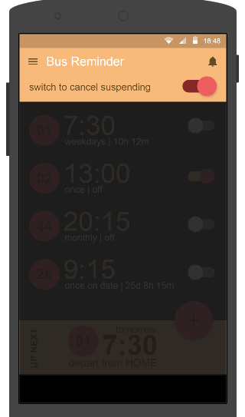

Figure 9.3.2: Suspend all reminder

|  |  |  |  |  |
| --- | --- | --- | --- | --- |
| **UC0034 – Suspend all reminder** | | | | |
| **Use-case No.** | <UC0034> | **Use-case Version** | | <1.0> |
| **Use-case Name** | Suspend all reminder | | | |
| **Author** | Anh TT | | | |
| **Date** | 29/05/2015 | **Priority** | <High > | |
| **Actor:**  User  **Summary:**  When user want to suspend all reminder.  **Triggers**  In Bus reminder’s screen, user will click on switch suspend all reminder to suspend all reminder.  **Preconditions:**  User must login to the app.  User’ phone must have internet  **Post Conditions:**  All reminder will be suspended.  **Main Success Scenario:**   |  |  |  | | --- | --- | --- | | **Step** | **User** | **System** | | 1 | Have logged into system as an admin |  | | 2 | Click on “Reading management ” then search for the reading document that they want to edit | Be displayeds search result as a table | | 3 | Click on “Edit” link | Be displayed “Edit reading” screen that contains the information of chosen reading with these elements:   * Code * Title * Level | | 4 | Edit reading document information and click “Edit” button | The system validates the input data and then save data into database | | 5 | Click on “VocabularyEdit” link | Be displayed “Edit vocabulary” screen that contains the information of chosen reading with these elements:   * Hiragana * Meaning * Kanji * Type | | 6 | Edit reading document information and click “Edit” button | The system validates the input data and then save data into database | | 7 | Click on “ArticleEdit” link | Be displayed “Edit article” screen that contains the information of chosen reading with these elements:   * Content * Question * Answer * Meaning | | 8 | Edit reading document information and click “Edit” button | The system validates the input data and then save data into database |     **Alternative Scenario:**   |  |  |  | | --- | --- | --- | | **At Step** | **User** | **System** | | 4 | Edit reading information then click to another link | Do not save edited data then redirect to selected page | | 6 | Edit reading information then click to another link | Do not save edited data then redirect to selected page | | 8 | Edit reading information then click to another link | Do not save edited data then redirect to selected page |   **Exceptions:**   |  |  |  | | --- | --- | --- | | **At Step** | **User** | **System** | | 4 | Edit reading information to be similar to another existed reading and click “Edit” button | The system validates the input data and return Error message and do not save edited data into database | | 6 | Edit reading information to be similar to another existed reading and click “Edit” button | The system validates the input data and return Error message and do not save edited data into database | | 8 | Edit reading information to be similar to another existed reading and click “Edit” button | The system validates the input data and return Error message and do not save edited data into database |   **Reference:**  UC0032- <Admin> Search reading document | | | | |
|  | | | | |

##### UC0037: Suspend a chosen reminder

Suspend a chosen reminder’s screen:

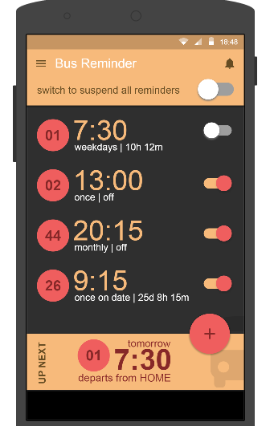

Figure 9.3.2: Suspend a chosen reminder

|  |  |  |  |  |
| --- | --- | --- | --- | --- |
| **UC0034 – Suspend a chosen reminder** | | | | |
| **Use-case No.** | <UC0034> | **Use-case Version** | | <1.0> |
| **Use-case Name** | Suspend a chosen reminder | | | |
| **Author** | Anh TT | | | |
| **Date** | 29/05/2015 | **Priority** | <High > | |
| **Actor:**  User  **Summary:**  When user want to suspend a chosen reminder.  **Triggers**  In Bus reminder’s screen, user will click on reminder that be chosen to suspend it.  **Preconditions:**  User must login to the app.  User’ phone must have internet  **Post Conditions:**  A chosen reminder will be suspended.  **Main Success Scenario:**   |  |  |  | | --- | --- | --- | | **Step** | **User** | **System** | | 1 | Have logged into system as an admin |  | | 2 | Click on “Reading management ” then search for the reading document that they want to edit | Be displayeds search result as a table | | 3 | Click on “Edit” link | Be displayed “Edit reading” screen that contains the information of chosen reading with these elements:   * Code * Title * Level | | 4 | Edit reading document information and click “Edit” button | The system validates the input data and then save data into database | | 5 | Click on “VocabularyEdit” link | Be displayed “Edit vocabulary” screen that contains the information of chosen reading with these elements:   * Hiragana * Meaning * Kanji * Type | | 6 | Edit reading document information and click “Edit” button | The system validates the input data and then save data into database | | 7 | Click on “ArticleEdit” link | Be displayed “Edit article” screen that contains the information of chosen reading with these elements:   * Content * Question * Answer * Meaning | | 8 | Edit reading document information and click “Edit” button | The system validates the input data and then save data into database |     **Alternative Scenario:**   |  |  |  | | --- | --- | --- | | **At Step** | **User** | **System** | | 4 | Edit reading information then click to another link | Do not save edited data then redirect to selected page | | 6 | Edit reading information then click to another link | Do not save edited data then redirect to selected page | | 8 | Edit reading information then click to another link | Do not save edited data then redirect to selected page |   **Exceptions:**   |  |  |  | | --- | --- | --- | | **At Step** | **User** | **System** | | 4 | Edit reading information to be similar to another existed reading and click “Edit” button | The system validates the input data and return Error message and do not save edited data into database | | 6 | Edit reading information to be similar to another existed reading and click “Edit” button | The system validates the input data and return Error message and do not save edited data into database | | 8 | Edit reading information to be similar to another existed reading and click “Edit” button | The system validates the input data and return Error message and do not save edited data into database |   **Reference:**  UC0032- <Admin> Search reading document | | | | |
|  | | | | |

## Non-functional Specification

### Reliability

* Mean time between failures: The mean time between each failure is expected to be about 480 hours of using.
* Mean time to repair: Immediately when Administrator finds out problem or website is attacked/hacked by someone. Average 1 day.
* The maximum bugs per function are 2 bugs/a function when user uses software within 2 months. The average number of bugs in the software during system testing is about to be around 1 bugs/1000 LOC.
* The database must be backed up daily and can be recovered if necessary

### Performance Requirements

#### Availability

The application must be available 95% of time. Users can access to it everywhere from their

Web browser with internet connection.

#### Response time

In term of response time, waiting time of processing will be 2 to 5 seconds; time to process any functions will not exceed 7 seconds.

### User Interface

● **Color:** The background color will be white and blue in default. The color of text will be black or white.

● **Text:** All texts bases on Helvetica style and title or label will use upper case with the first letter.

### Maintainability

* **Coding standards and naming conventions**
  + Output of the project must include coding standards and naming conventions documentations. Implementation code must be easy to maintain.
  + All code must be clearly commented, including class, method documentations.
  + If some components are reused, the documentations of those components must also be included.
* **Design**
  + The design of the system must be loosely coupled that chances on some module will not affect others.
* **Logging**
  + All the errors should be logged, supporting for bug fixing and maintenance.
  + All strange or sensitive situations should also be logged.

### Usability

Usability Requirements support the following from the perspective of its primary users:

● **Efficiency of use:** user can complete each function in less than 12 actions

● **Intuitiveness:** all help/error messages are simple to understand; user can know exactly how to do each feature after one time using it.

### Security Requirements

In order to avoid unwanted access by strangers, the security implemented in various ways:

* **User layer**: Each function must be distributed system access and manipulate the individual parts. To edit information, user must declare their username and password before the operation. Functions will be show after users login dependencies user’s role and permission of each user.
* **Manage Data Layer**: Only Administrator can modify database system.
* **Stored Data**: All data about information of user, tested, etc.. will be saved in My SQL Server, and be easy for data classification or backup..

### Hardware/Software Requirements

● **Hardware requirement:** PC/Laptop (window 7, window 8, window XP…)

● **Software requirements:** Web browser (Chrome, Firefox, IE…) with internet connection